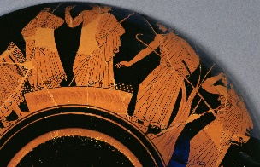
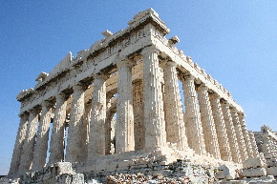
NORTHSIDE
Respect, Pride, Inclusion, Challenge, Creativity, Resilience

Dear Parents/Carers,
We hope you had a great half-term! Our Big Question this half term is:

What is the legacy of the Ancient Greeks?
Key dates:
Friday, 27th March – Forest School – Group 1
Monday 2nd March – St David’s Day – Wear Yellow
Tuesday 3rd March – M & M Productions – Alice in Wonderland
Wednesday 4th March – Holi Day
Thursday, 5th March – World Book Day
Friday, 6th March – Forest School – Group 2
Thursday 12th March – Greek Day (dress up as a Greek)!
Friday, 13th March – Forest School – Group 1
Tuesday 17th March – St Patrick’s Day – wear green
Friday 20th March – Forest School – Group 2
Monday 23rd March – School Trip to the British Museum
Tuesday, 26th March – Thursday 26th March – Assessment Week
Wednesday, 25th March – French Exchange Day

English | We will be exploring, planning, writing or performing two genres: narrative writing and an explanation text. We will be focusing on:  - creating contrasting atmospheres  - using dashes and colons  - using an impersonal style  - writing in chronological order  - using the present perfect tense  - adverbials  - conjunctions  - the passive voice  Our extended writing outcomes will include writing extracts of a known story with contrasting atmospheres and an explanation text about a complex task.
Reading   | Our Terrific Text this half term is ‘The Adventures of Odysseus’ by Daniel Morden and Hugh Lupton. We will also be reading non-fiction books about the Ancient Greeks. We will be focusing on the following reading skills:  - retrieving information from our different text types  - identifying themes within texts  - summarizing the main ideas within texts  - explaining the meaning of new words in context  - making inferences and using supporting evidence  - evaluating how writers use language  - using intonation, pace and expression in performance poetry  - checking texts make sense and using ‘repair’ strategies
Maths   | We will be learning about:  - decimals up to two decimal places and equivalent fractions – tenths, hundredths and thousandths  - ordering and comparing decimals  - rounding decimals  - percentages and their equivalent fractions and decimals  - perimeter
  Science | We will be completing our unit of work on properties and changes of materials, including:  - materials dissolving to form solutions  - methods for separating mixtures  - reversible and irreversible changes
Foundation subects:  Each subject has dedicated time, weekly.        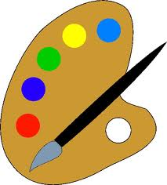      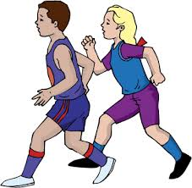     | French: We will be describing body parts, consolidating year 3 topics and describing brothers’ and sisters’ features.  Music: We will be preparing for the Barnet Schools Music Festival, singing in unison and solos, using expression for performance and learning percussion parts to perform with the songs.  PE: In PE, we will be learning the skills of cricket, including the overarm throw, cross bat shots, bowling accurately and target zone games.  Dance: We will be exploring using expressive vocabulary to enhance movement quality and dynamics focusing on Greek Gods.  DT: We will be learning about frame structures, designing, creating and evaluating our own.  Humanities: In history, we will be exploring the legacy of the Ancient Greeks, including democracy, sports, buildings, society and their beliefs.  RE: We will be focusing on the topic: ’What is our situation?’  RSHE: We will be considering bias in the media, allocation of resources, responsibility for the environment and routes into work.  Computing: We will be continuing with our understanding of programme on Micro: bits.

We have a new Year 5 vocabulary overview which can be found on our class page of the new website. This will help you to support your children as they learn the new vocabulary for each half-term. Please follow this link:
https://theflourishingschoolsfed.ovw3.devwebsite.co.uk/attachments/download.asp?file=1541
Places to visit:
The Science Museum has a free exhibit about the Ancient Greeks and their links with philosophy and science. https://www.sciencemuseum.org.uk/what-was-on/ancient-greeks-science-and-wisdom

The Sir John Soane Museum has things to see about the Ancient Greeks, including a twilight tour:
https://www.soane.org/whats-on/twilight-tour-19-April-2025

Things to remember:
Mondays: spelling test
Mondays and Wednesdays: children to wear PE kit
Wednesday: times tables test

Homework expectations:
The homework expectation is:
- reading daily (20-30 minutes every day)
- spellings to learn and be tested on Mondays
- MyMaths tasks set once a week, to be completed by Monday each week
- Spelling Shed games set once a week, to be completed by Monday each week
- Times Table Rockstars several times a week

Please ensure that your child brings their Reading Record into school every day, with a comment from the previous evening (using the reading questions bookmark) and your signature.

Your child may receive some extra homework if it is felt that it would be beneficial for them to complete additional tasks.

Contact information:
year5@northsideprimary.co.uk to arrange a meeting or discuss issues specific to your child.
07707135568 - text or call with any issues/questions/suggestions that need a speedier response.

Thank you for your ongoing support.

The University of Nottingham Team
Mr Marshall
Mrs Angelova
Miss Sobczyk

