THE QUEENSWELL FEDERATION
CALCULATION POLICY
Policy Written by: Spencer Clayton
Date Written: February 2021
Date for Review: 2025


Addition and Subtraction
EYFS F1 | EYFS F2 | Year 1 | Year 2
Children have some concept of number and numerals and their relation to quantity.  They explore mathematics through a range of open-ended and natural resources and use these to demonstrate their understanding of number, shape, space and measures. | Children have a secure understanding of numerals and their relation to quantity.  They confidently use maths throughout their play (e.g. using money in their role play; measuring when building or counting to measure time).  They are able to make use of mathematical concepts to solve problems, including during sustained shared thinking with others. | Read, write and interpret mathematical statements involving addition (+), subtraction (–) and equals (=) signs  Represent and use number bonds and related subtraction facts within 20  Add and subtract one-digit and two-digit numbers to 20, including zero | Solve problems with addition and subtraction: using concrete objects and pictorial representations, including those involving numbers, quantities and measures  Recall and use addition and subtraction facts to 20 fluently, and derive and use related facts up to 100  Add and subtract numbers using concrete objects, pictorial representations, and mentally, including:  - a two-digit number and ones  - a two-digit number and tens  - two two-digit numbers  - adding three one-digit numbers

Year 3 | Year 4 | Year 5 | Year 6
Add and subtract numbers mentally, including: a three-digit number and ones a three-digit number and tens a three-digit number and hundreds  Add and subtract numbers with up to 3 digits using formal written methods of column addition and subtraction | Add and subtract numbers with up to 4 digits using the formal written methods of column addition and subtraction | Add and subtract numbers mentally with increasingly large numbers  Add and subtract whole numbers with more than 4 digits, including using formal written methods  Adding and subtracting decimal numbers up to three decimal places | Add and subtract whole numbers with more than 4 digits, including using formal written methods  Adding and subtracting decimal numbers up to three decimal places

Addition
Key language: more, increase, jump on, count on, add, altogether, sum, total, parts and wholes, ‘is equal to’, ‘is the same as,’ ‘is balanced’, partition, exchange, commutative, inverse, estimate, formal written method

Developing mental strategies for addition: children should be taught all methods and encouraged to choose the method which is most appropriate for the calculation/ they feel most comfortable using
Partitioning  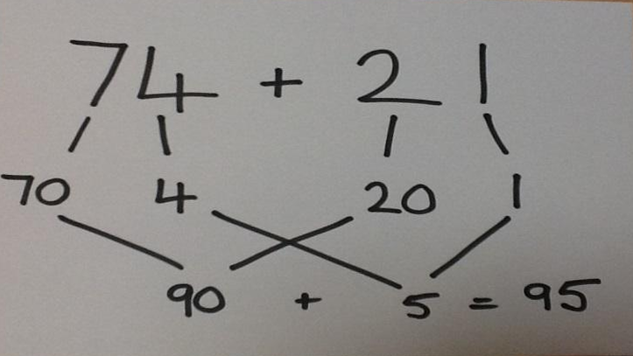  Children partition using jottings or mentally and then add ones and tens (and hundreds and thousands) | 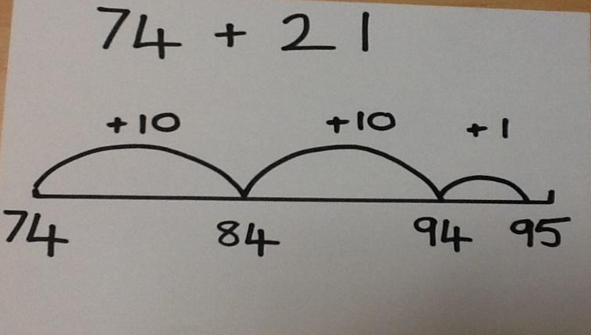  Counting on from biggest number  Children to start with biggest number and partition smallest so they can jump in multiples of 10 and then 1s
Compensating  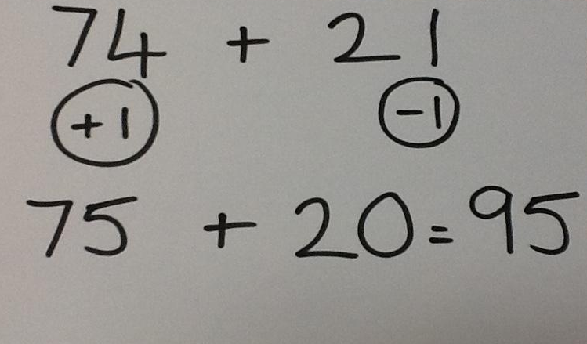  This method is about recognising near multiples of ten and requires understanding that 2 numbers can be partitioned and added in any order  74 + 21 = 70 + 4 + 20 + 1 | 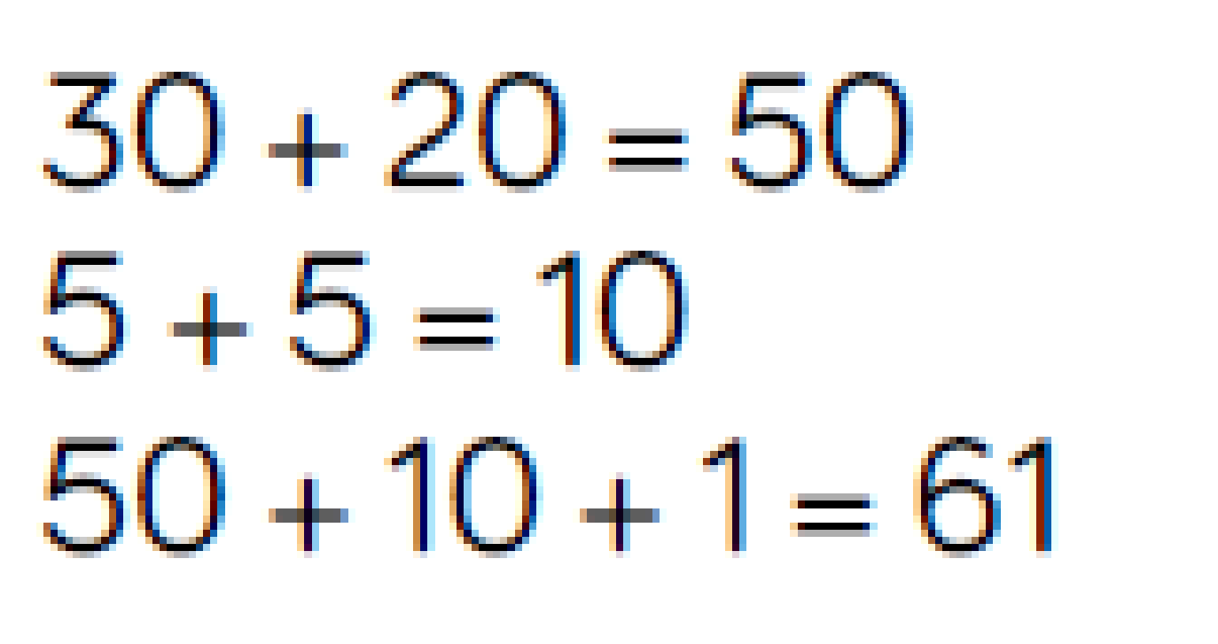  Looking for ways to make 10.  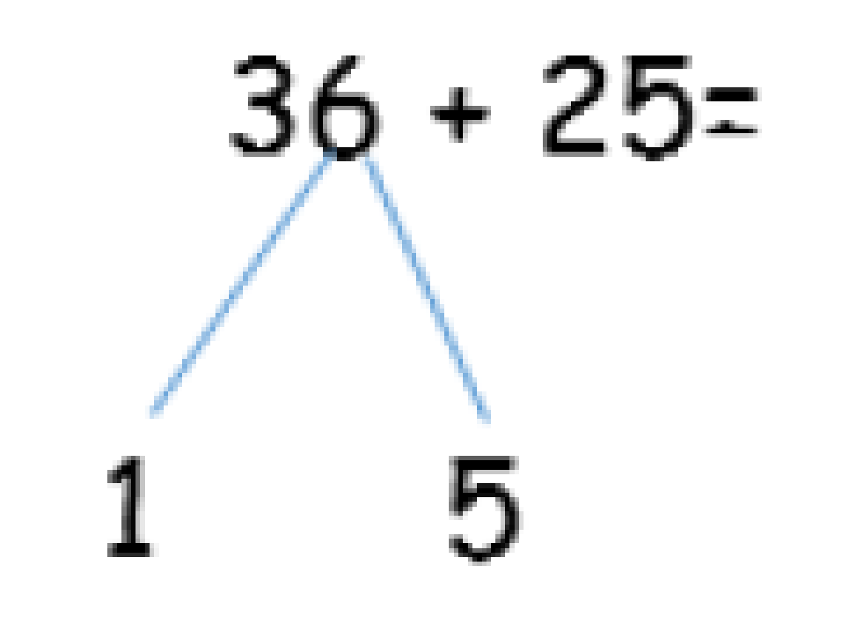

Written methods for addition:
 | Concrete | Pictorial | Abstract
EYFS | 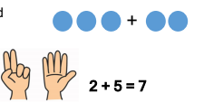      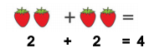  Children understand what ‘more’ means and can show one more using concrete resources.  Children begin to combine groups of objects or pictures and use concrete resources. |  | Number lines can be used alongside practical resources to solve addition calculations. Children can ‘jump’ or ‘count on’.  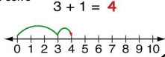
Adding 1 digit numbers (within 10) | 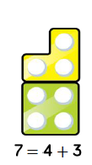  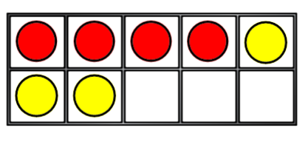  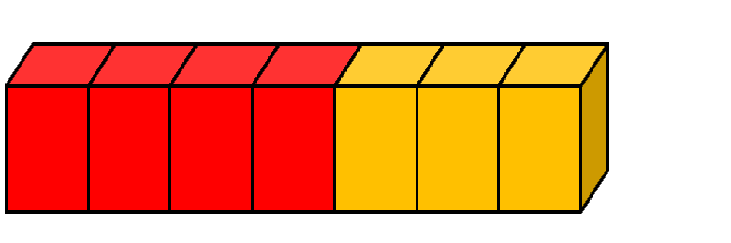  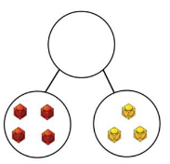    When exploring adding numbers to 10 children can explore aggregation (combining 2 or more quantities) and augmentation (increasing a quantity by another quantity) | 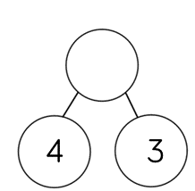  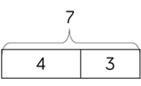  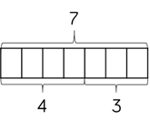  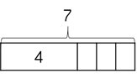  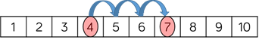  The part – whole model, bar model, number shapes and ten frame support aggregation.  The combination bar model, ten frame, bead string and number track all support augmentation. | 4 + 3 = 7  3 + 4 = 7  Children should be able to recognise that addition is commutative and the meaning of =  7 = 3 + 4  7= 4 + 3
Adding 1 and 2 digit numbers (crossing 10) | 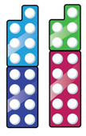  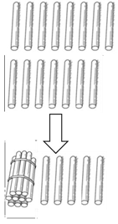  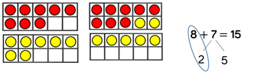    When adding one digit numbers that cross tens, it is important to highlight the importance of 10 ones equalling one ten.  Different manipulatives can be used to represent this exchange. | Use concrete resources alongside number lines to support children in how to partition jumps.  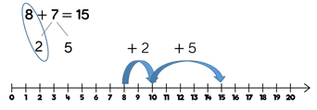  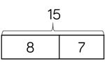  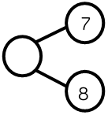 | 8 + 7 = 15  For adding 2 digit numbers in Year 2, children use partitioning into 10s and 1s rather than the formal written method. This is supported by concrete resources/ pictures.  12 + 18 =30  10 + 2 + 10 + 8 =30
Formal written method without having to exchange.  Year 5 and 6 use Dienes and place value counters for decimal numbers | Add together the ones first and then the tens, hundreds etc Start with Dienes, straws or place value counters  323 + 231 =  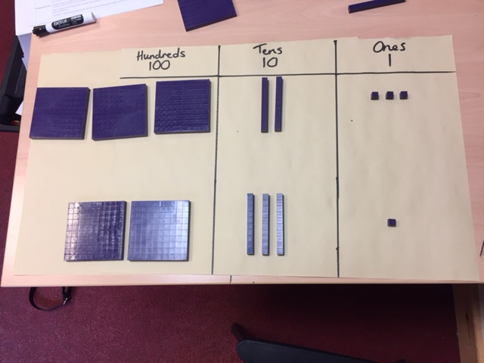 | Children to represent Dienes in a place value chart  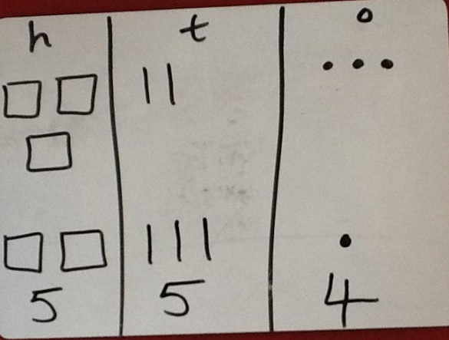 | Children might still want to label their place value columns to help  H T O  3 2 3  + 2 3 1  5 5 4
Column method – having to exchange  Year 5 and 6 use Dienes and place value counters for decimal numbers | Physically exchanging ones for tens/ tens for hundreds etc  243 + 368 =  Use of place value counters or Dienes to show HTO + TO and then HTO + HTO  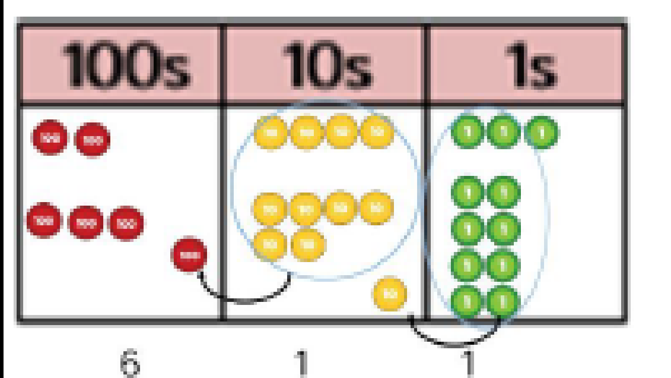  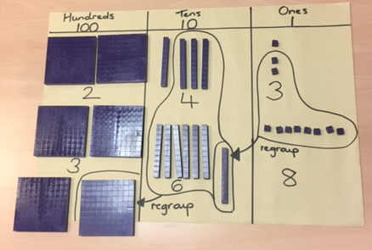 | Children to represent numbers in a place value chart, circling when they make an exchange  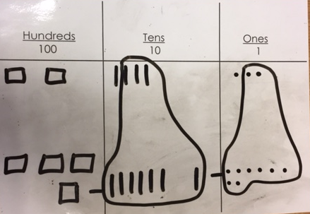  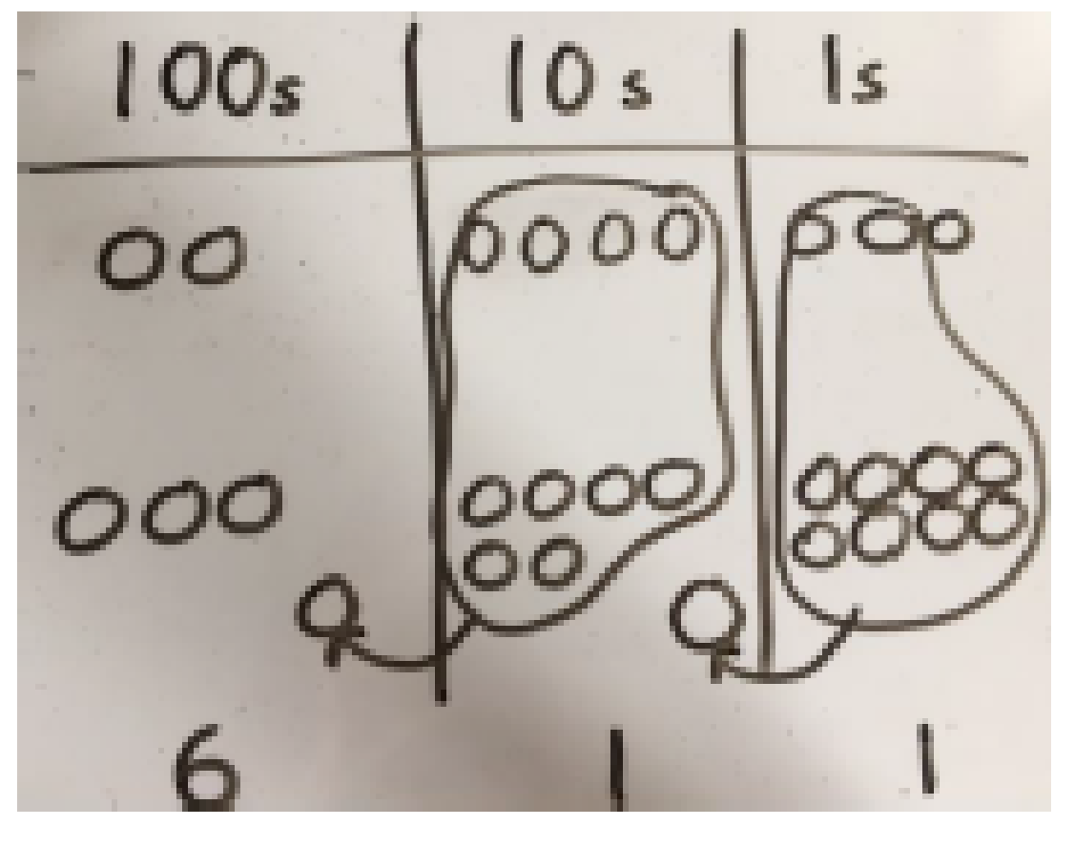 | Expanded method to aid understanding. Children should be adding from the right (starting with ones) and initially writing the calculations for ones tens and hundreds alongside)  243  + 368  11 (8 + 3)  100 (60 + 40)  500 (300 + 200)  611  Regrouping recorded in the correct place value column (above the numbers)  HTO  1 1  243  + 368  611

Conceptual Variation: Different ways to ask children to solve 21 + 34
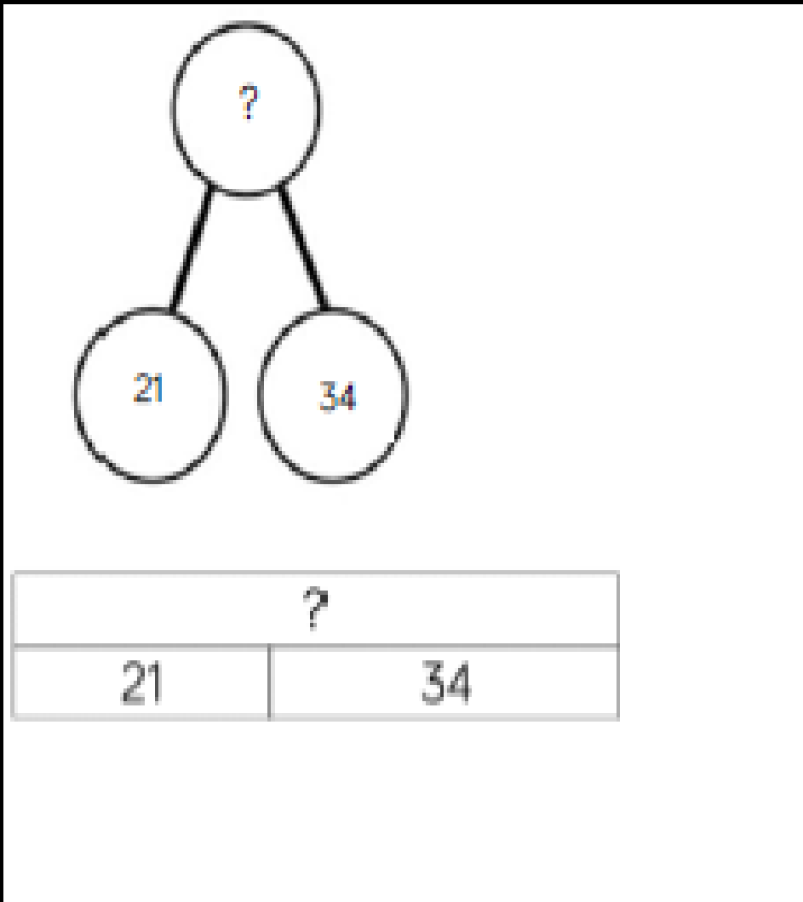 | 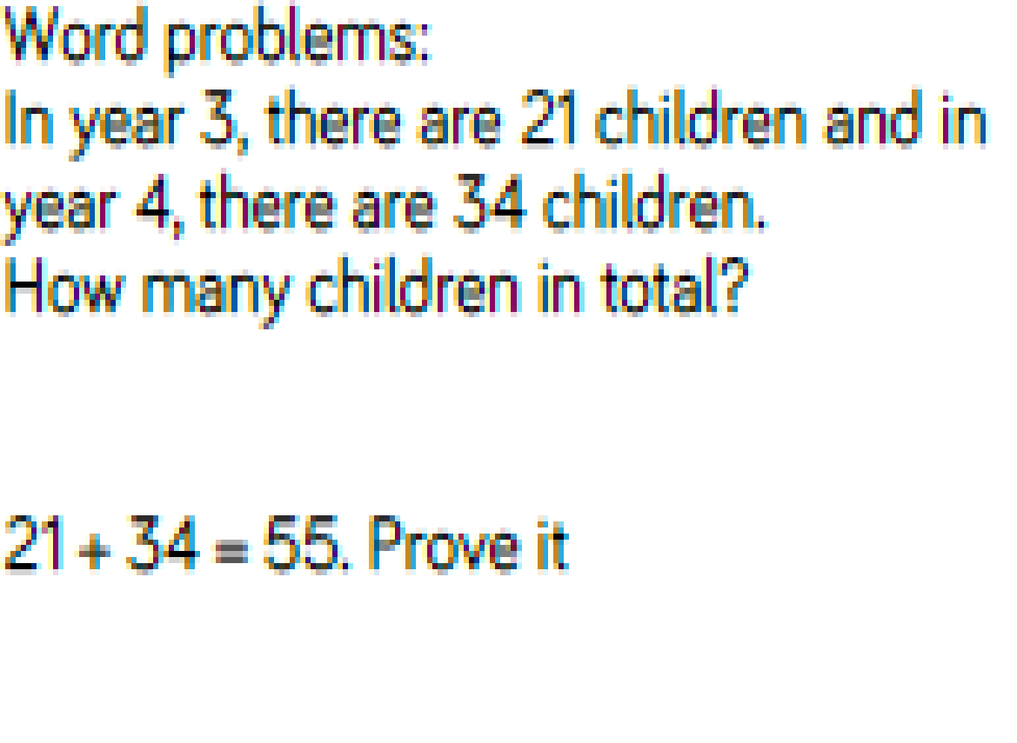 | 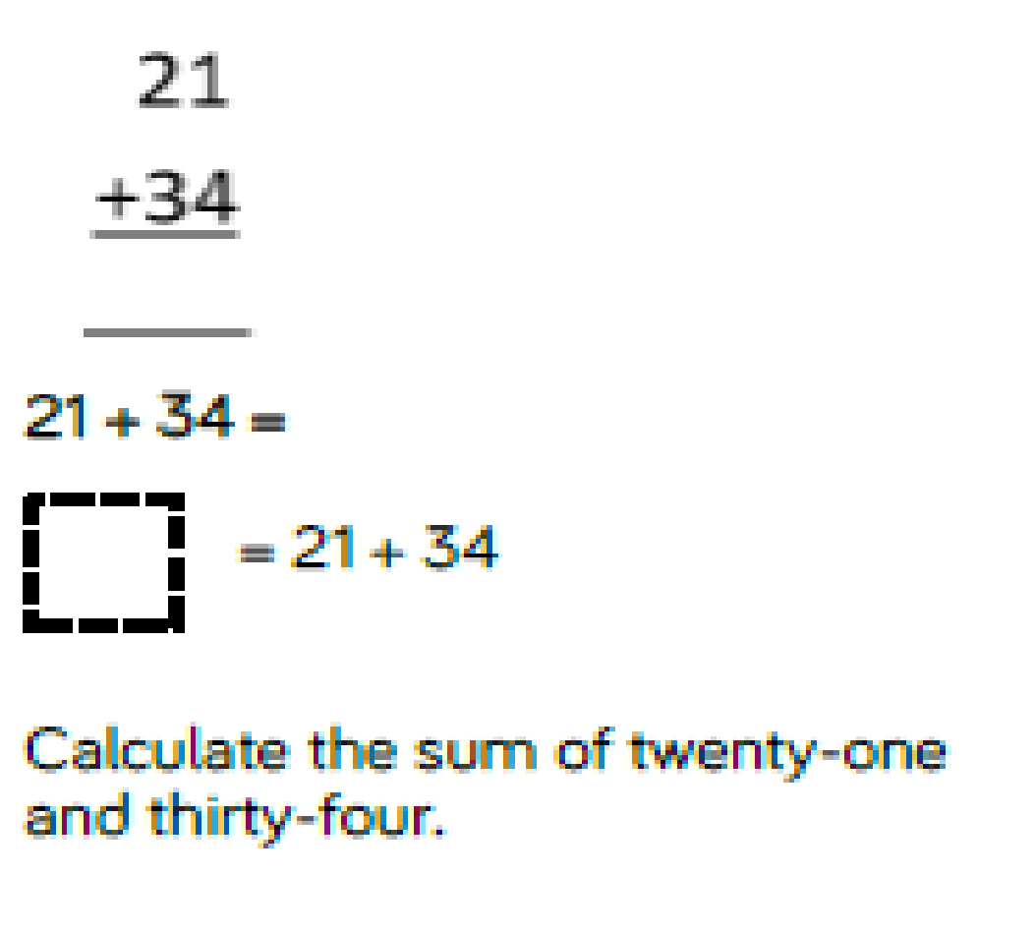 | 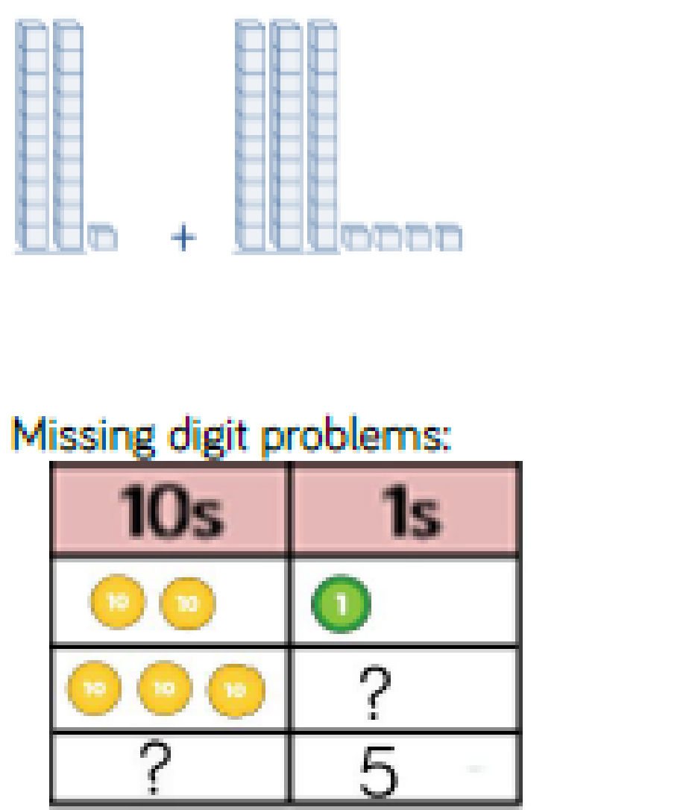

Subtraction
Key language: less, subtract, take away, fewer, difference, minus, decrease, exchange, inverse, estimate, formal written method

Developing mental strategies: children should be taught all methods and encouraged to choose the method which is most appropriate for the calculation/ they feel most comfortable using
Counting back from largest number on a number line  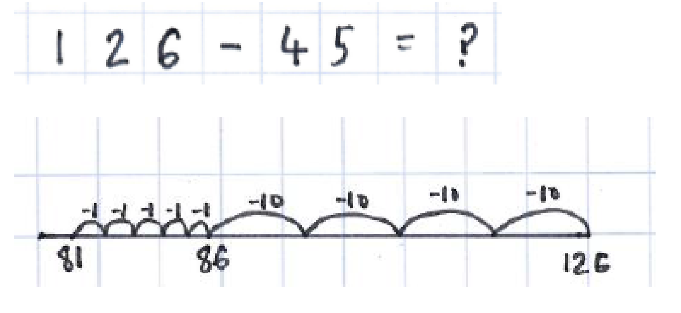  The jumps are recorded above the representation. Subtracting tens before moving onto ones. | Finding the difference (bridging through 10) by counting on from the smallest number  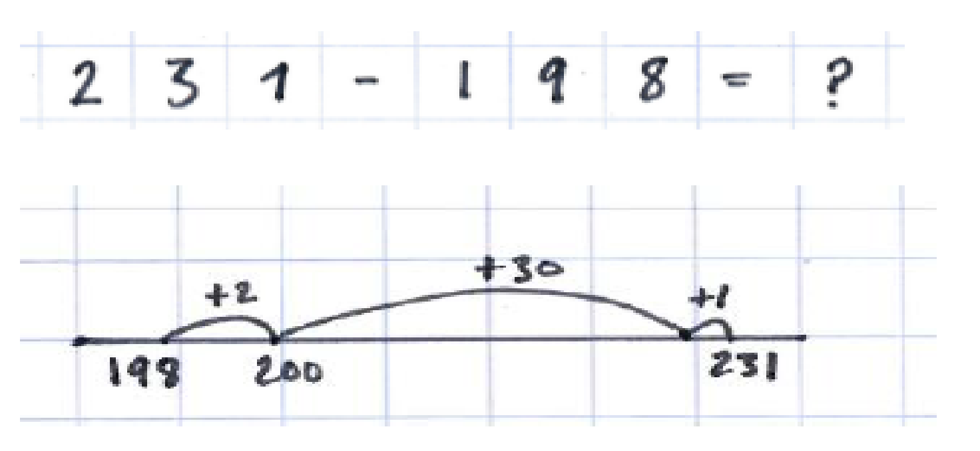  The first jump should be to the next multiple of ten followed by counting in multiples of ten before adding any remaining ones.  Another strategy would be to count in tens first and then ones.
Partitioning  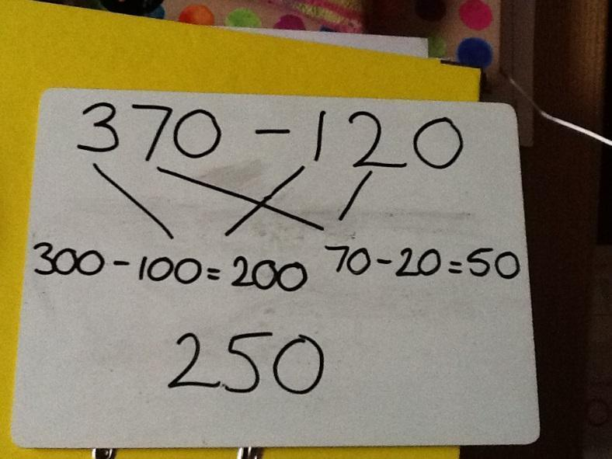  370 – 120 = | Compensating  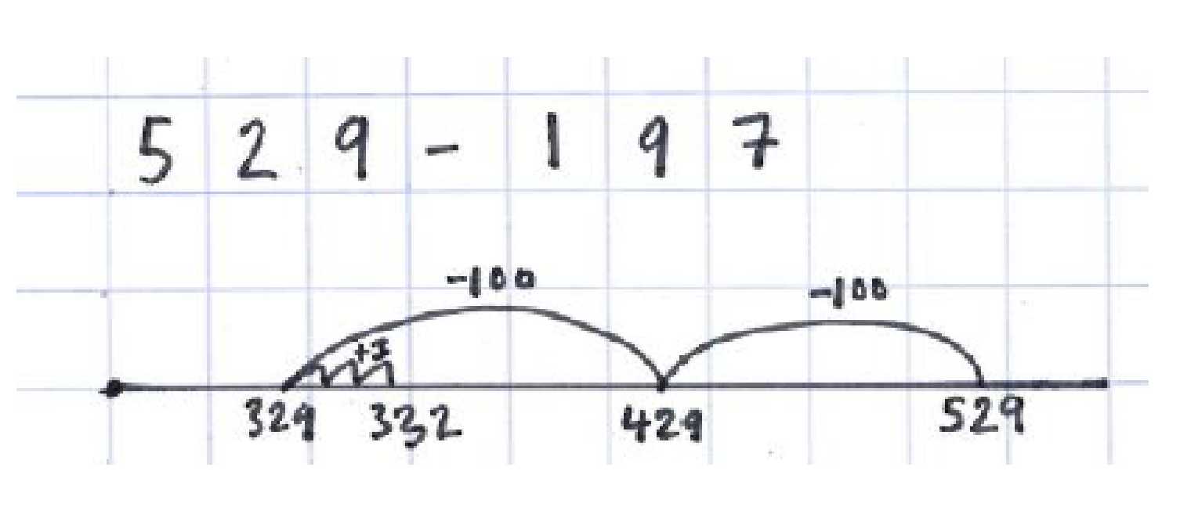  Children might recognise that numbers are near multiples of 10 or 100.  They can count back and then count on the difference  529 – 197  529 – 200 (+3)

Written methods for subtraction:
 | Concrete |  | Pictorial |  |  | Abstract
EYFS | 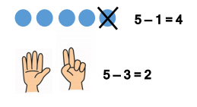    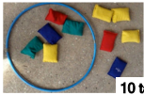  Children begin to use objects, pictures and concrete resources to relate subtraction to taking away and counting how many objects. |  |  |  |  | Number lines can be used alongside practical apparatus to solve calculations and ‘jump back’.  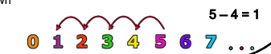
Subtract 1 digit numbers within 10 | 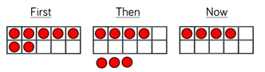  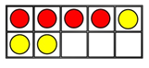  Ten frames and number shapes support partitioning.  Ten frames and bead strings support reduction.  Cubes can support finding the difference. |  | 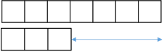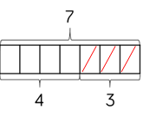  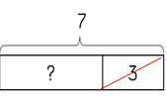  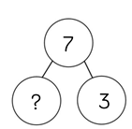  Part-whole models and bar models support partitioning and number tracks and number lines support reduction and finding the difference. |  |  | 7 – 4 = 3  7 – 3 = 4  Children should be able to write calculations to show each part subtracted from the total.  3 = 7 – 4  4 = 7 - 3
Subtracting 1 and 2 digit numbers to 20 | 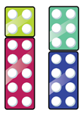  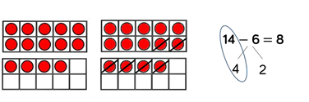  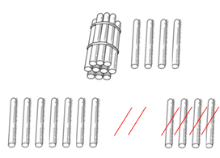  When subtracting 1 digit numbers that cross 10, it is important to highlight the importance of 10 ones equally 1 ten. |  | 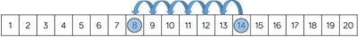  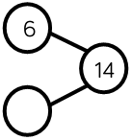  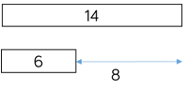  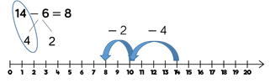  Children should be encouraged to find the number bond to 10 when partitioning the subtracted number. |  |  | 14 – 6 = 8  14 – 8 = 6  Children should be able to write calculations to show each part subtracted from the total.
Formal written method for subtraction with no exchange.  Year 5 and 6 use Dienes and place value counters to represent decimal numbers. | Children can use Dienes to make larger number  231 – 120 =  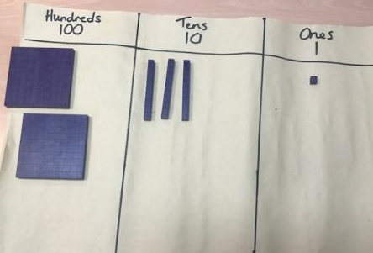  They then physically take the smaller number away starting with the ones  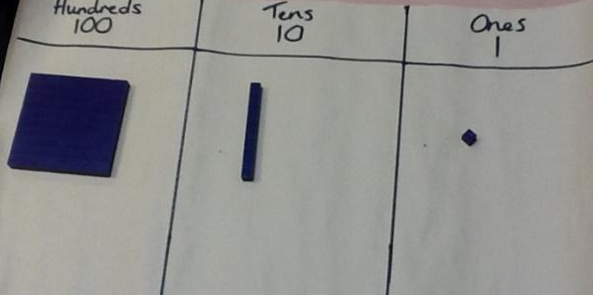 |  | Children represent Dienes pictorially.  231 – 120 =  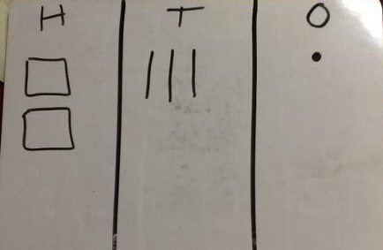  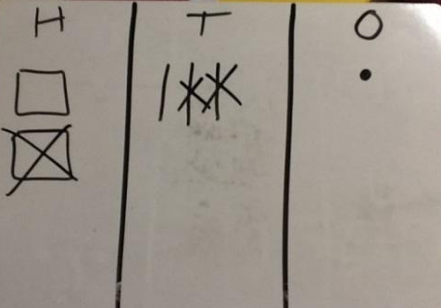  They can cross/ rub out to take away ones first and then tens |  |  | Children can start column subtraction by partitioning their numbers into place value columns  200 + 30 + 1  - 100 + 20 + 0  100 + 10 + 1 = 111  Formal written method: Get children at first to clearly label tens and ones. Always start by subtracting ones.  H T O  2 3 1  - 1 2 0  1 1 1
Column subtraction having to exchange | 231 – 126 =  Start by partitioning 231  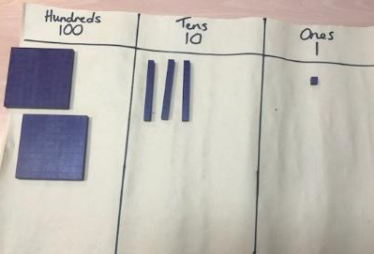  Exchange one ten for ten ones  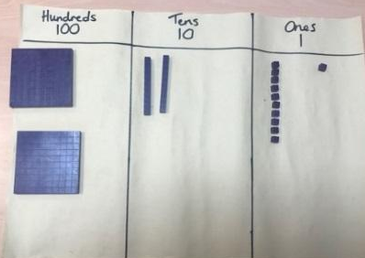  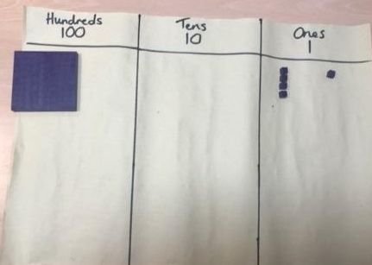  Subtract the ones and then the tens and hundreds by removing them |  | Represent Dienes pictorially remembering to show exchange  231 – 126 =  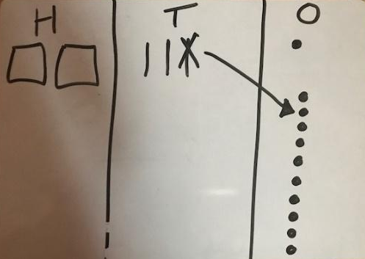  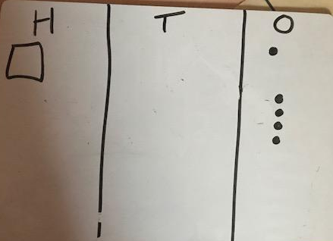  Cross or rub out 126 starting with the ones |  |  | 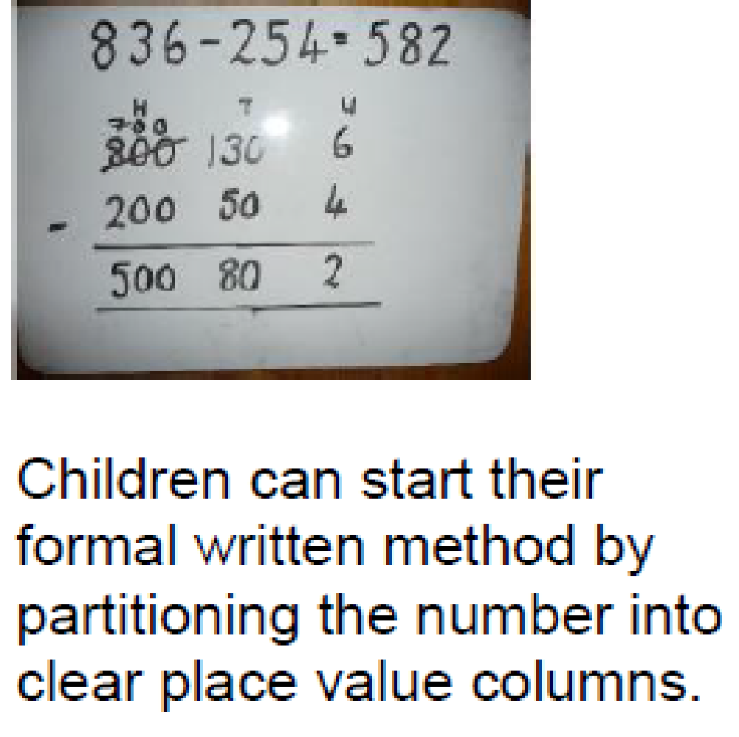  Formal written method. Get children to label place value columns and make sure they cross out numbers when exchanging and write new number above  H T O  2 1  2 3 1  - 1 2 6  _1__0_ 5

Conceptual variation: different ways to ask children to solve 391 – 186
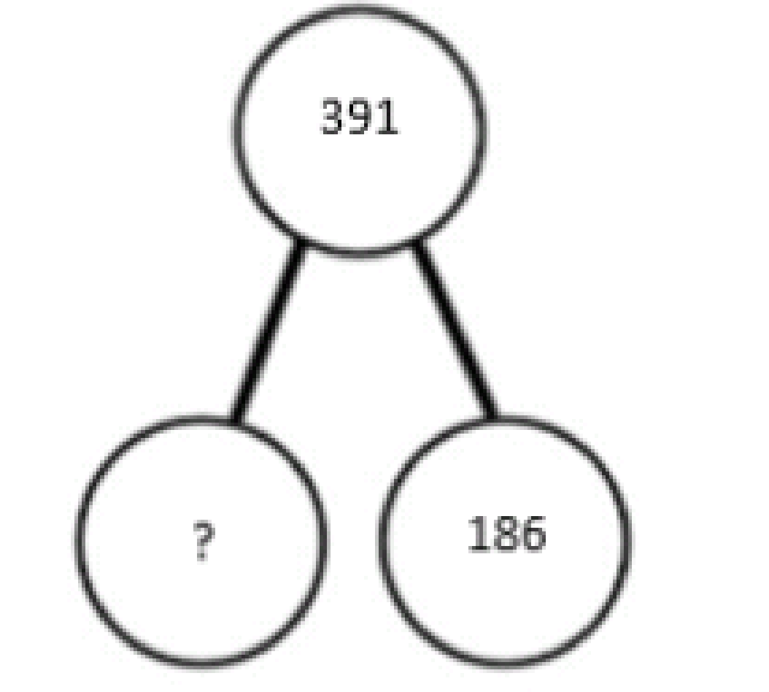  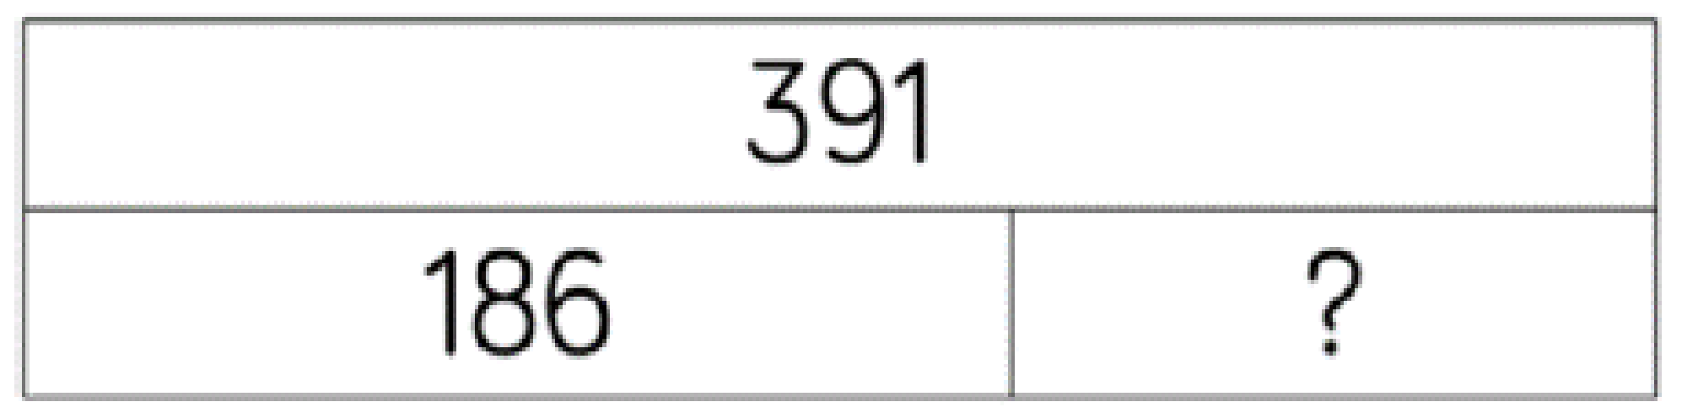 |  | 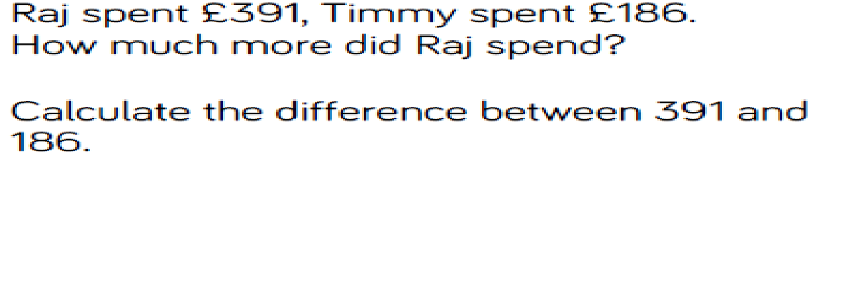 |  | 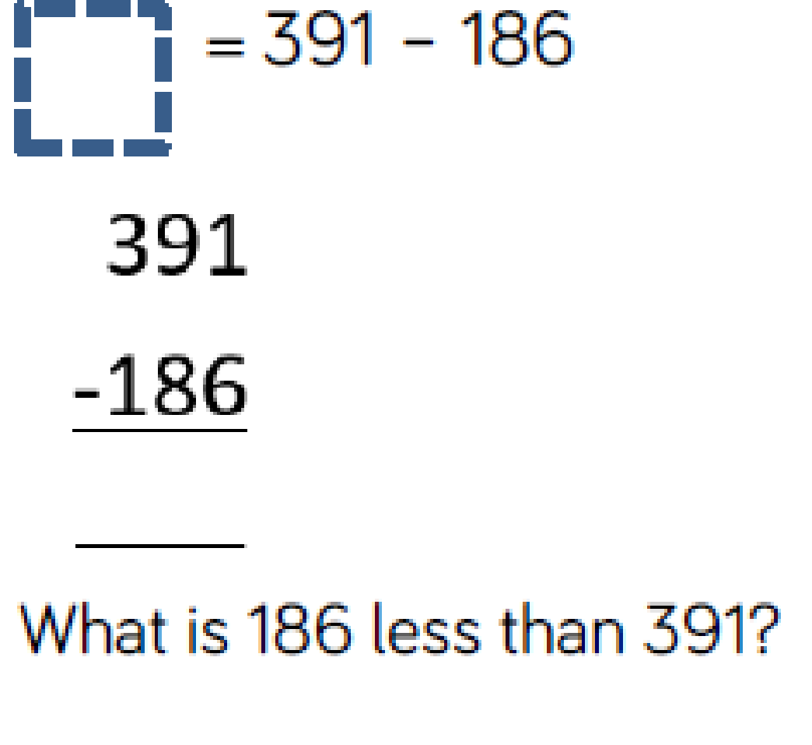 | 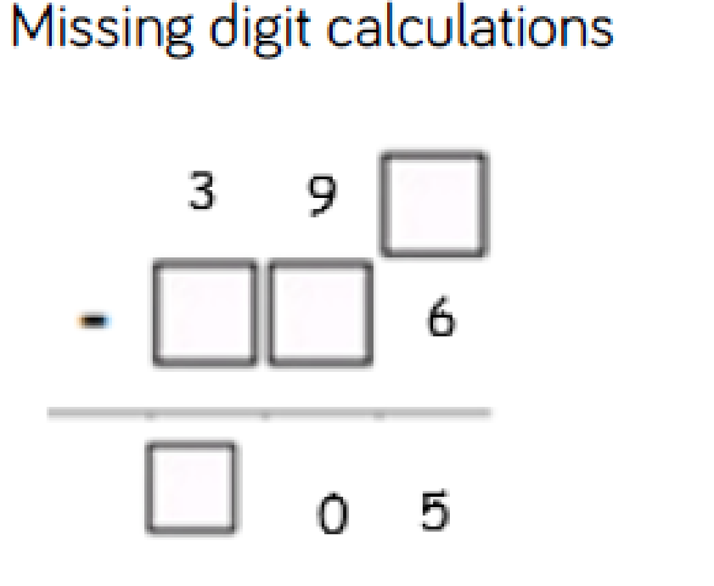

Multiplication and Division
EYFS | Year 1 |  | Year 2
Solve multiplication problems set in a real life context and solve through counting.  Children are introduced to doubling facts  Halving by sharing into 2 groups | Solve one-step problems involving multiplication and division, by calculating the answer using concrete objects, pictorial representations and arrays with the support of the teacher. |  | Recall and use multiplication and division facts for the 2,5 and 10 times tables.  Calculate mathematical statements for multiplication and division within the multiplication tables and write them using the multiplication (×), division (÷) and equals (=) signs
Year 3 |  | Year 4 | Year 5 | Year 6
Recall and use multiplication and division facts for the 3, 4 and 8 times tables.  Write and calculate mathematical statements for multiplication and division using the multiplication tables that they know, including for two-digit numbers times one-digit numbers, using mental and progressing to formal written methods |  | Recall and use multiplication and division facts for the 6, 7, 9, 11 and 12 times tables.  Multiply two-digit and three-digit numbers by a one-digit number using formal written layout | Multiply numbers up to 4 digits by a one- or two-digit number using a formal written method, including long multiplication for two-digit numbers  Divide numbers up to 4 digits by a one-digit number using the formal written method of short division and interpret remainders appropriately for the context | Multiply multi-digit numbers up to 4 digits by a two-digit whole number using the formal written method of long multiplication  Divide numbers up to 4 digits by a two-digit whole number using the formal written method of long division, and interpret remainders as whole number remainders, fractions, or by rounding, as appropriate for the context  Divide numbers up to 4 digits by a two-digit number using the formal written method of short division where appropriate, interpreting remainders according to the context.

Multiplication
Key language: repeated addition, multiply, double, times, multiplied by, equal groups, lots of, multiple, factor, product, formal written method, array, commutative, scaling
 | Concrete |  | Pictorial |  | Abstract
Times tables  (Year 2 – 6) | 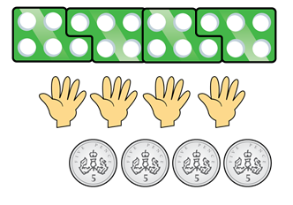  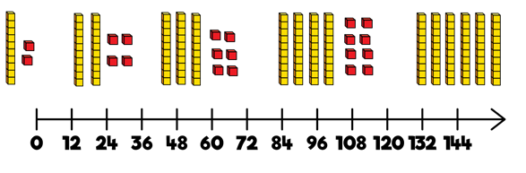  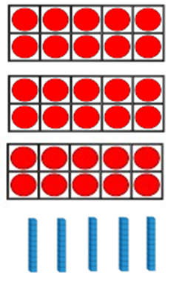   |  |   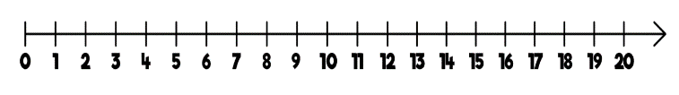  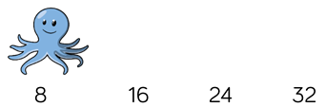    Use arrays to show that multiplication is commutative and the link between multiplication and division.  Encourage daily counting in multiples both forwards and backwards. This can be supported using a number line. |  | 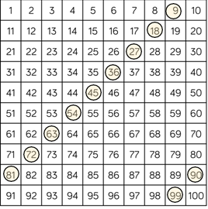  Looking for patterns in multiples and making links between the different times tables.
  6 | 12 | 18 | 24 | 30
  36 | 42 | 48 | 54 | 60
  66 | 72
EYFS | 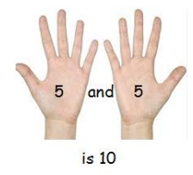  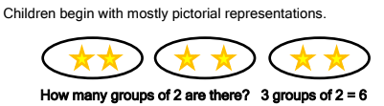  The link between addition and multiplication can be made through doubling and reinforced through repeated addition of the same number  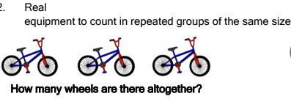
Repeated addition/ grouping | 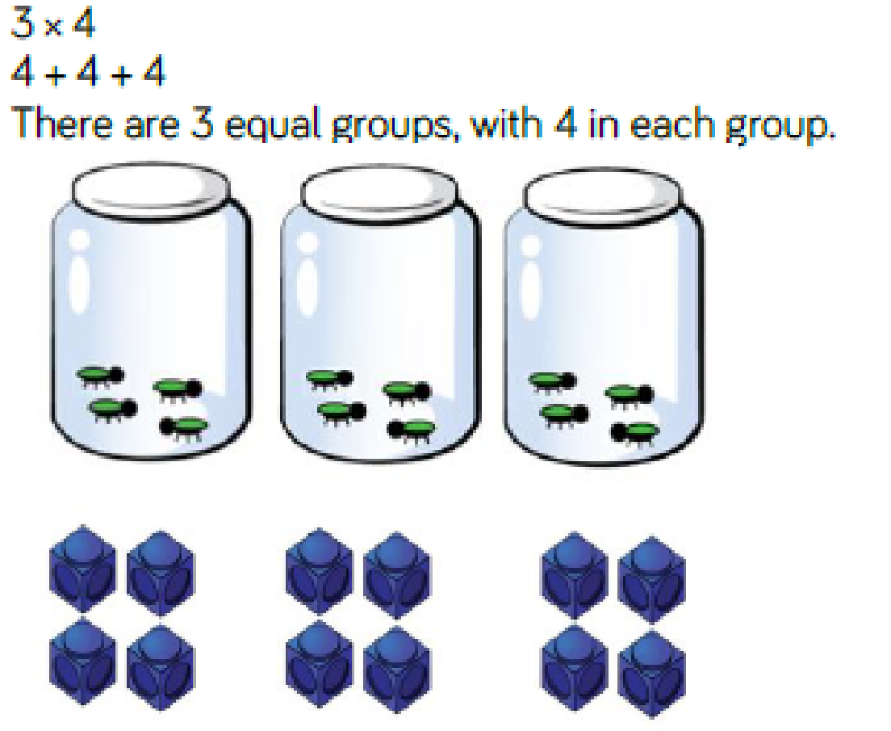 |  | 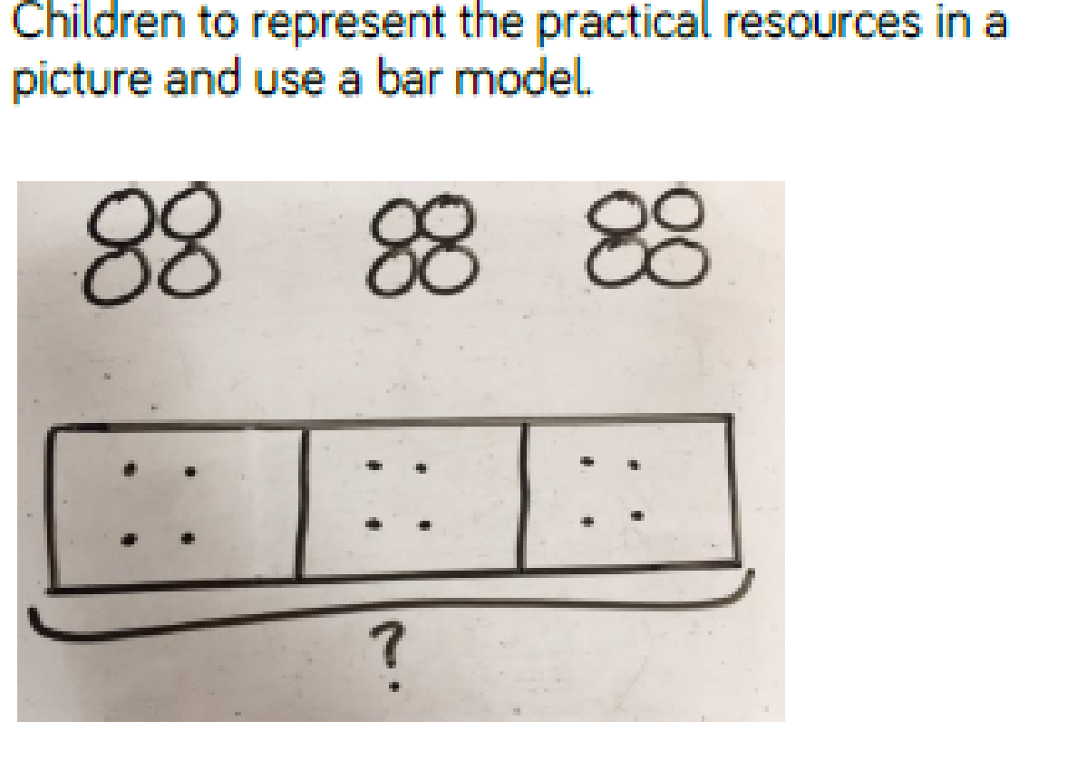 |  | 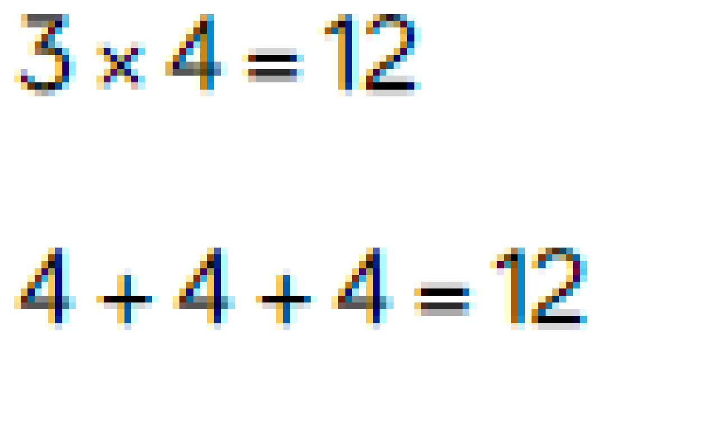
  12
  4 | 4 | 4
Repeated addition on a number line | 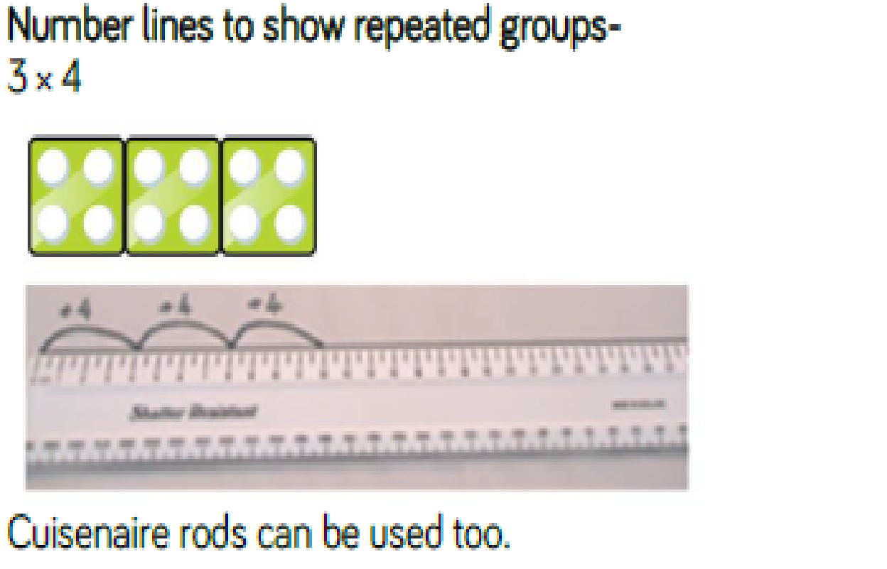 |  | 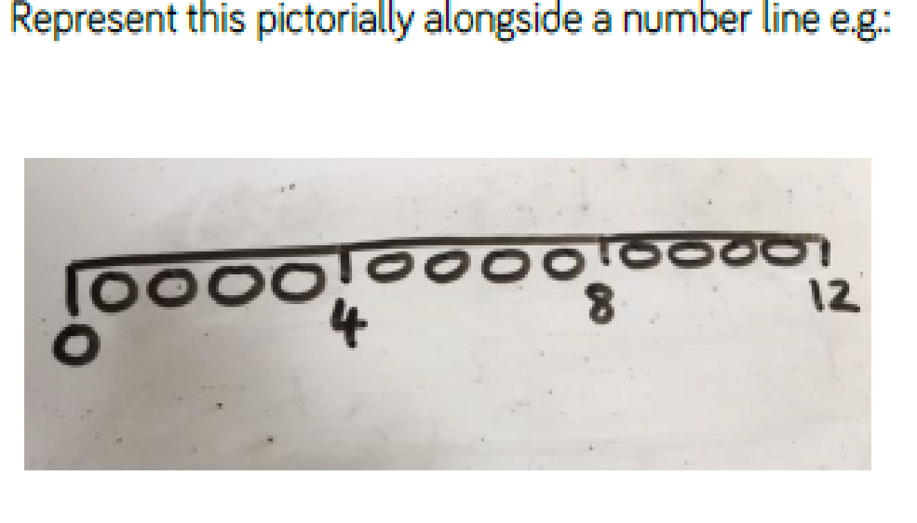 |  | 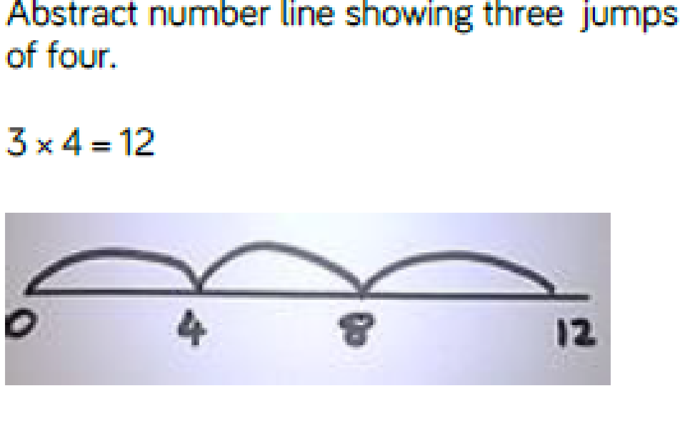
Arrays | 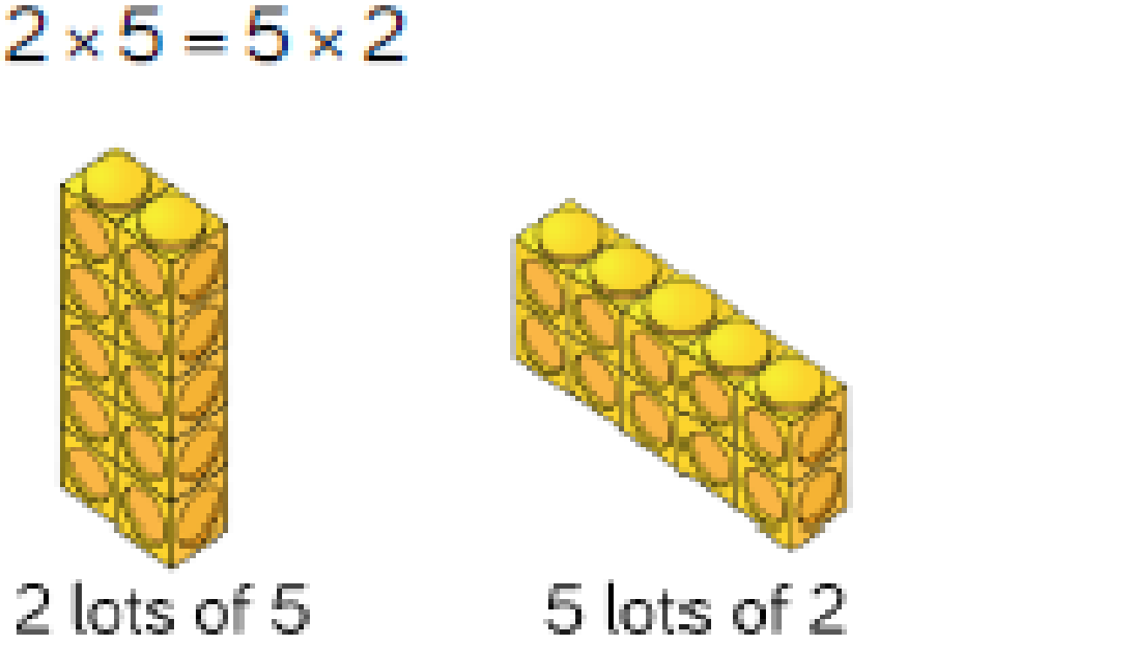  Use arrays to show commutivity. Counters and other resources can also be used. |  | 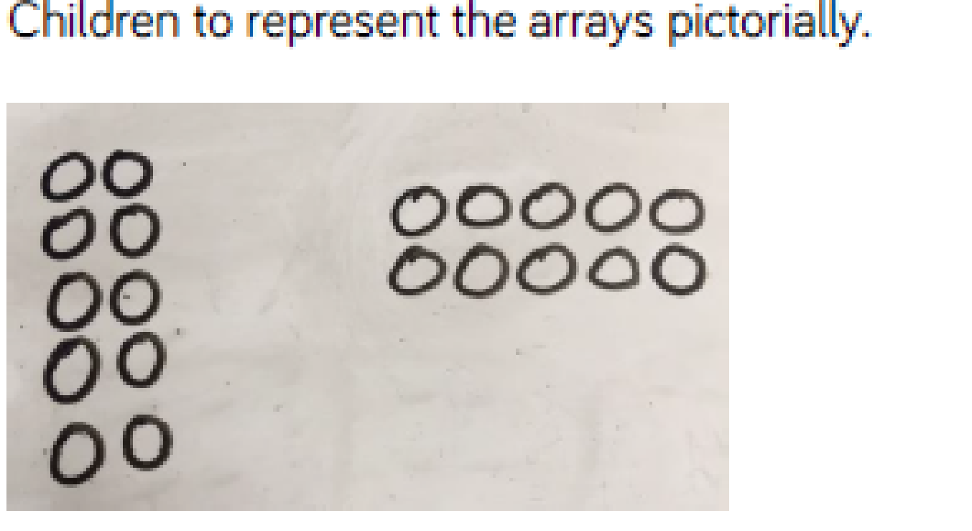 |  | 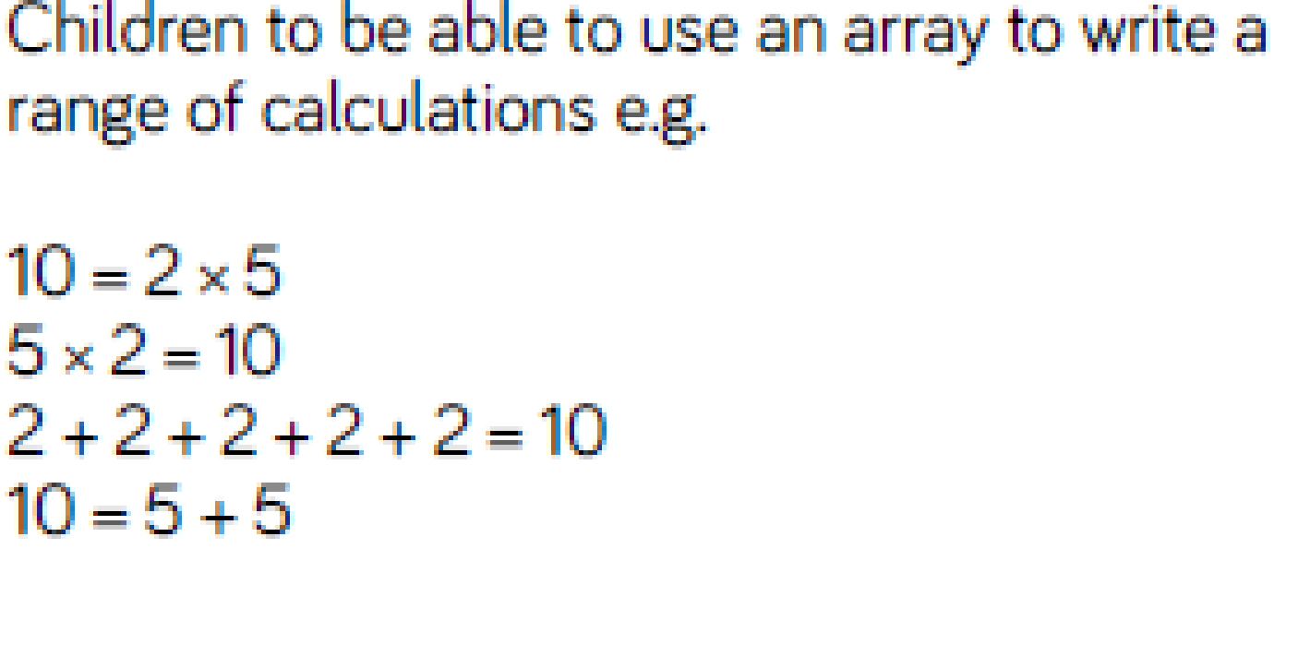
Partitioning | 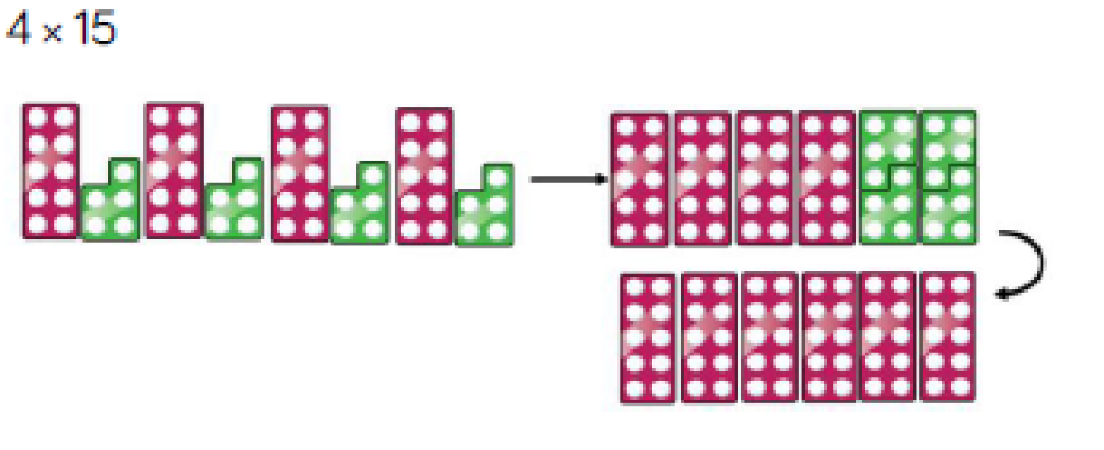  Partition to multiply using number shapes, Dienes or Cuisenaire rods |  | 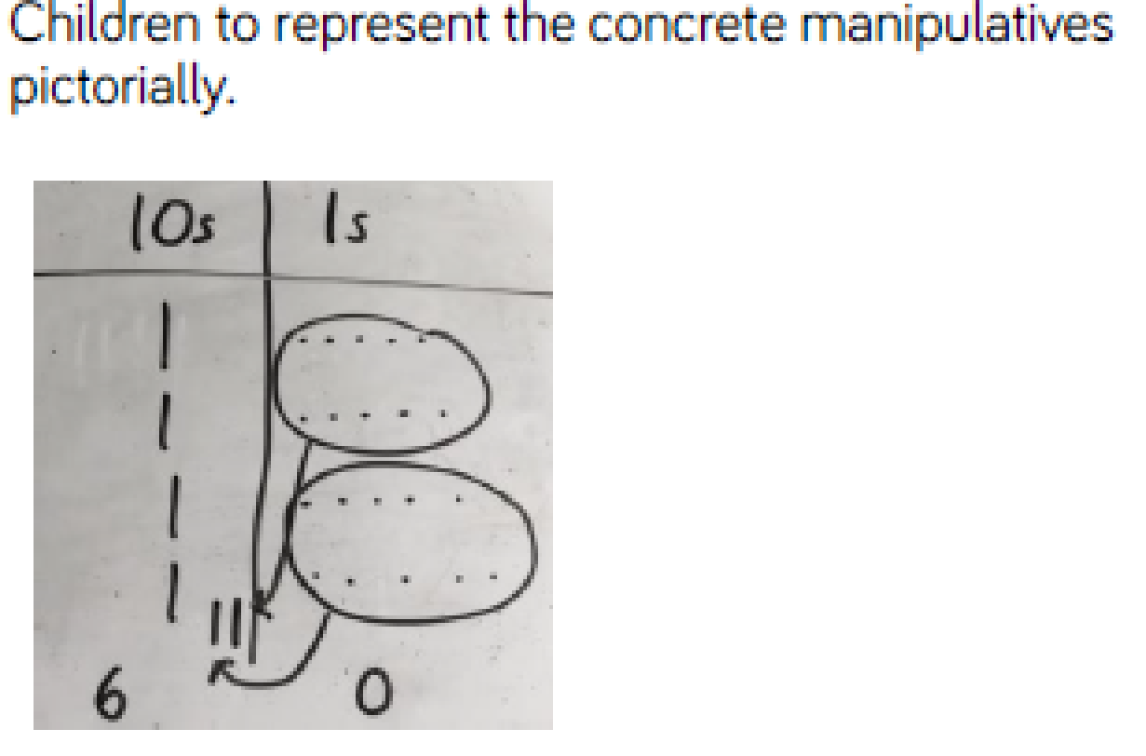 |  | 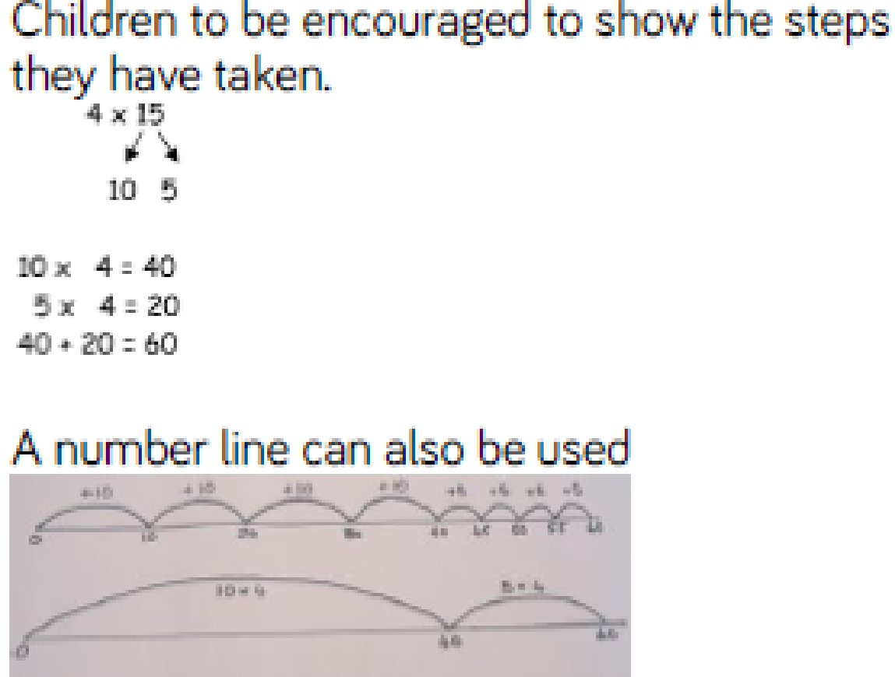
Column method | 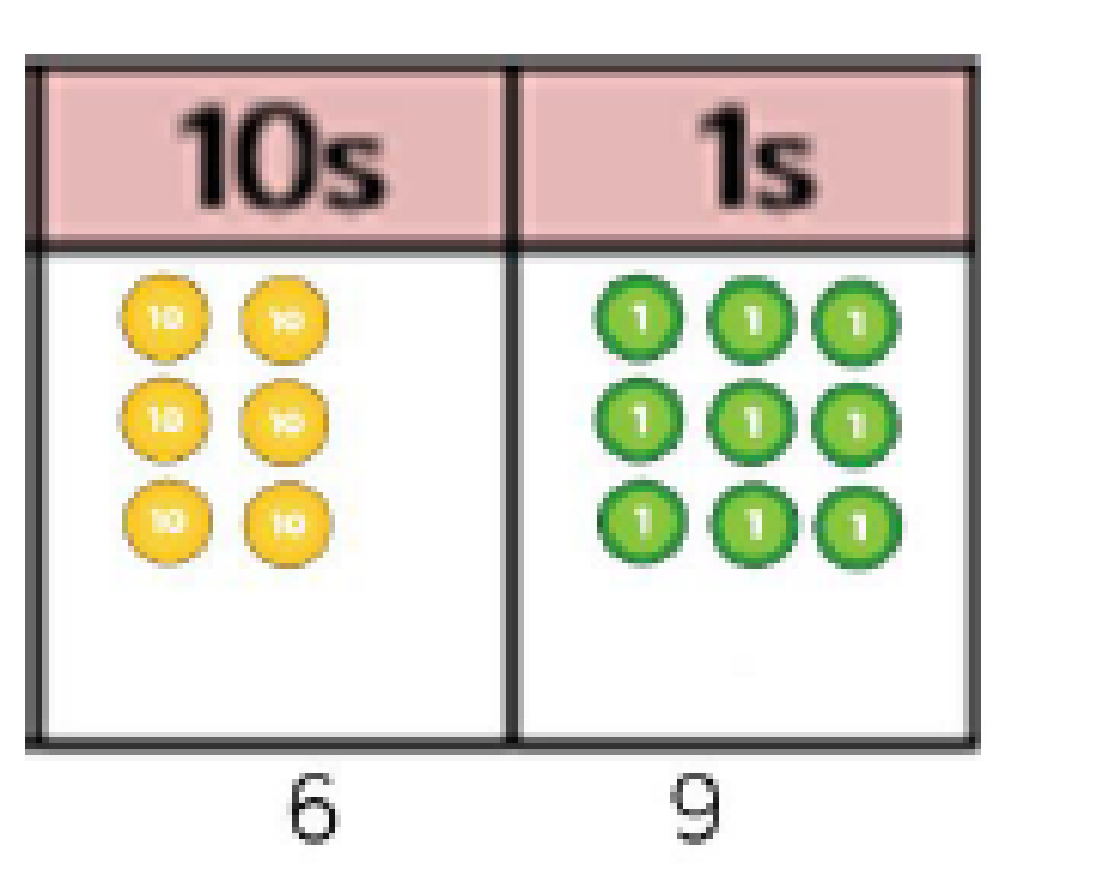  Use place value counters, Dienes or number shapes to show lots of in place value columsn  23 x 3 = 69 |  | 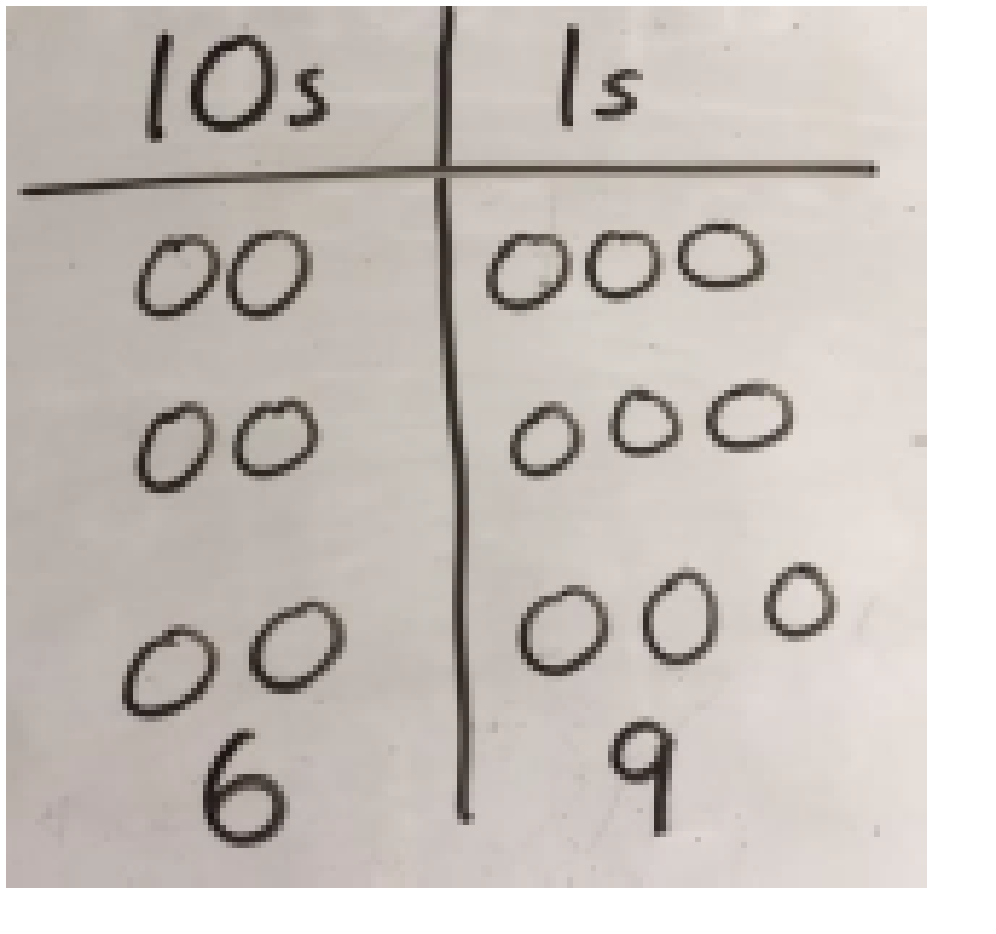  Children to represent concrete manipulatives pictorially |  | 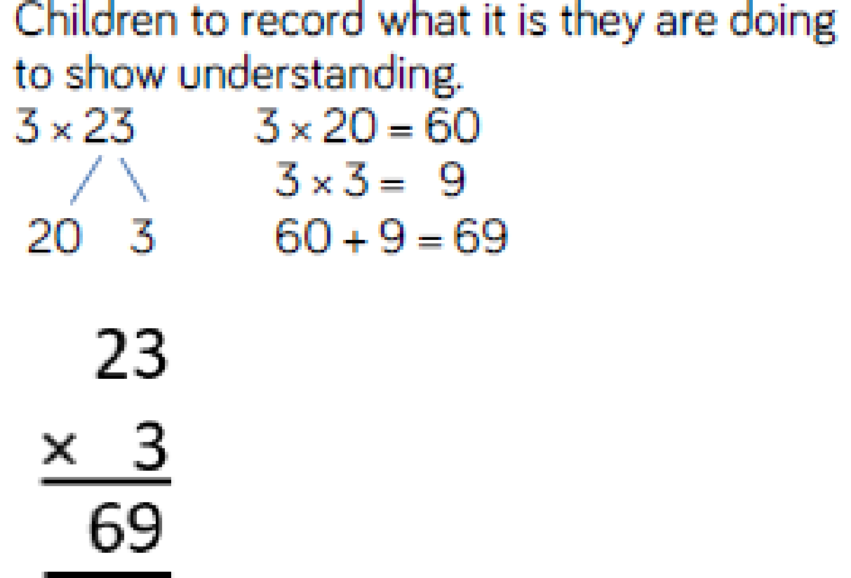
Formal written method | 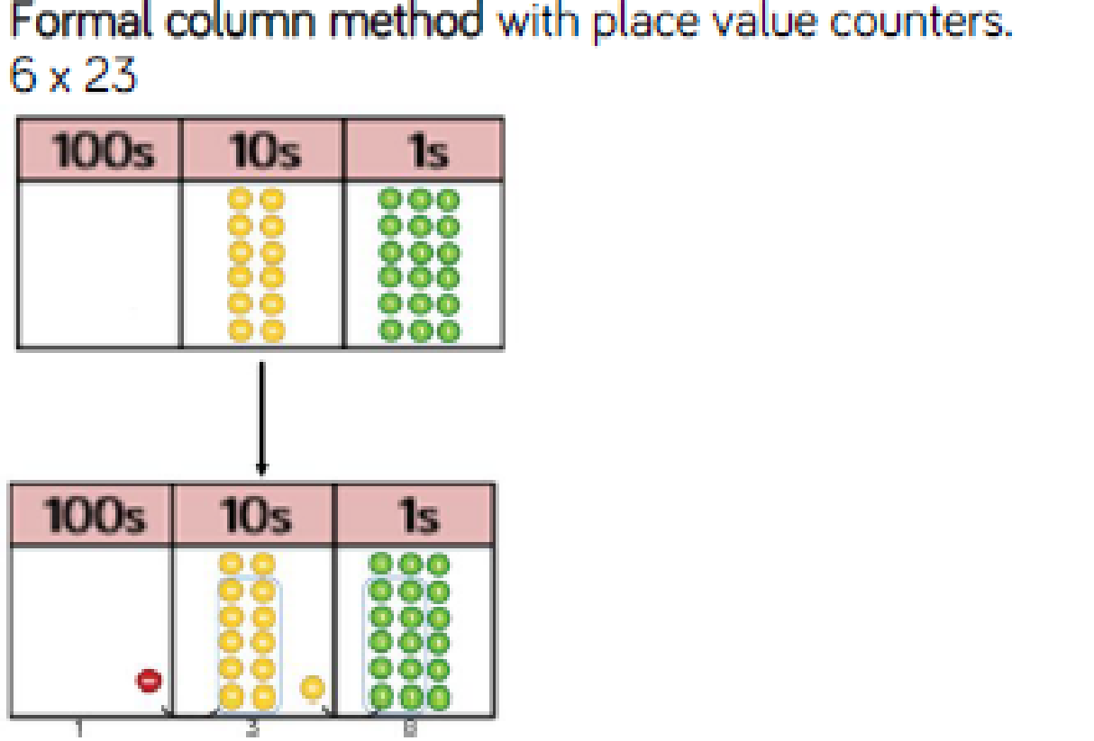 |  | 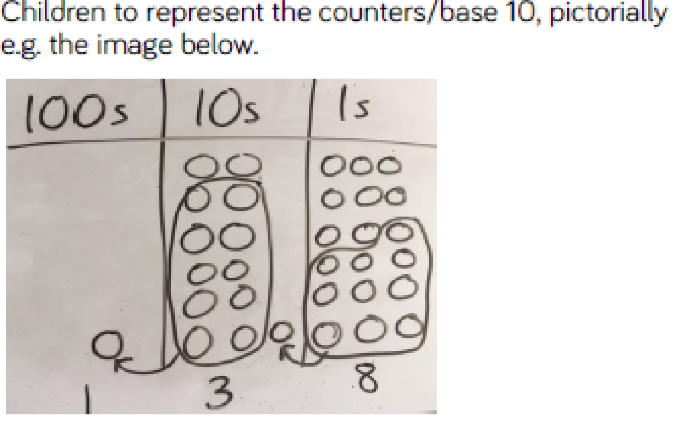 |  | 6 x 23  2 3  X 6  1 8 (6 x 3)  1 2 0 (6 X 20 )  + 1 3 8  1  2 3  X 6  1 3 8  If numbers are carried over into next column then this is shown above in correct place value column.
When children start to multiply 3 digit x 3 digit and 4 digit x 2 digit etc, they should be confident with the abstract and have clear steps to follow:  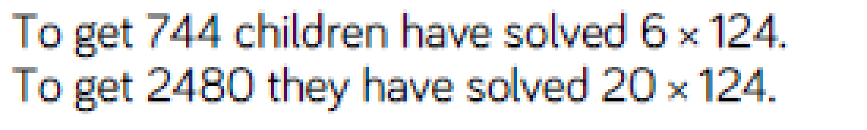 |  |  |  |  | 124 x 26  1 2  1 2 4  X 2 6  7 4 4  2 4 8 0  3 3 2 4  - 1  Children should record any exchanges above in the correct column and then when they have moved onto the next column should cross out ny numbers they no longer need.

Conceptual Variation; different ways to ask children how to solve 6 x 23
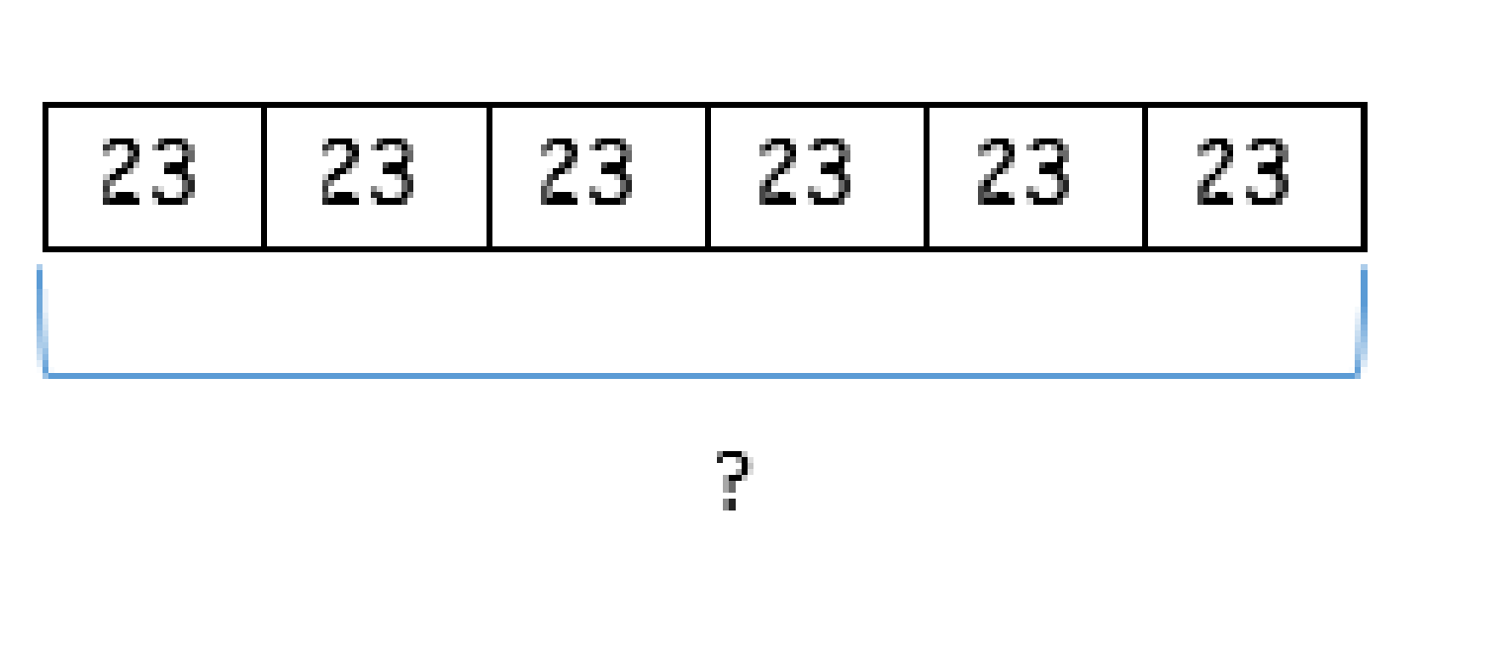 |  | 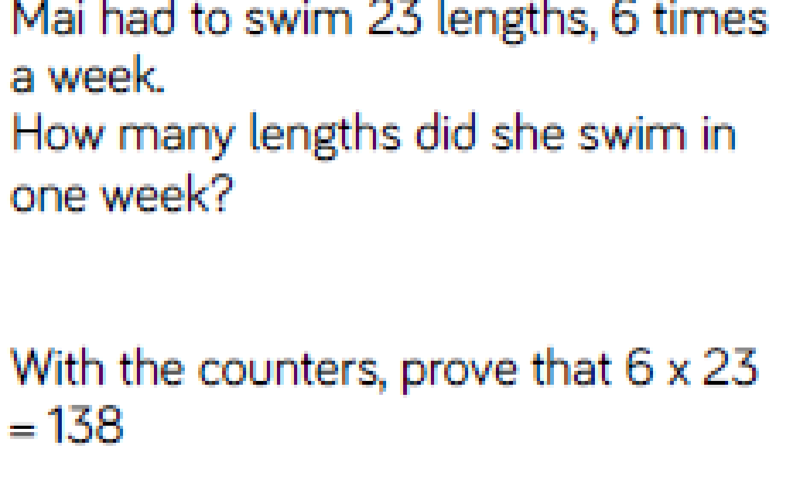 |  | 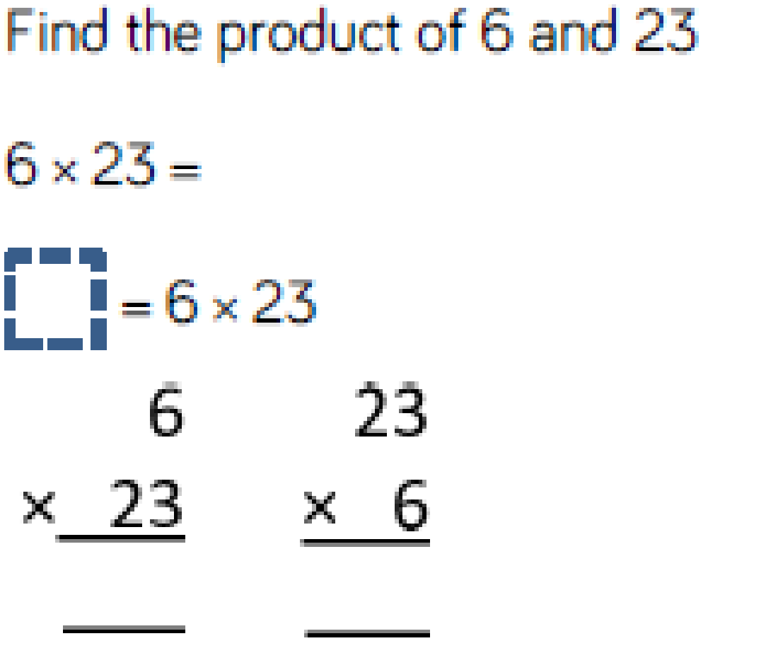 |  | 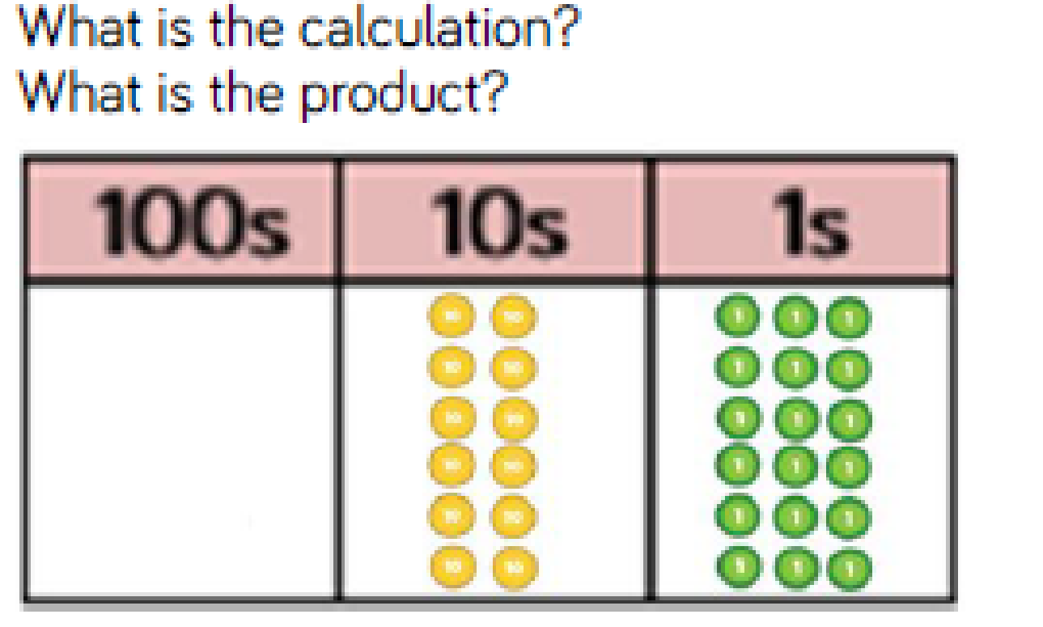

Division
Key language: halving, sharing, equal groups, lots of, divide, divided by, dividend, divisor, quotient, remainder, inverse0049
 | Concrete |  | Pictorial |  | Abstract
EYFS | 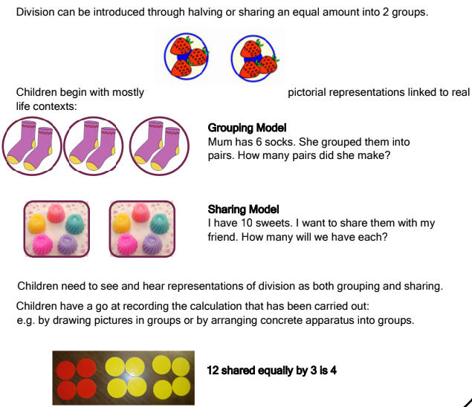
1 step problems (sharing) | 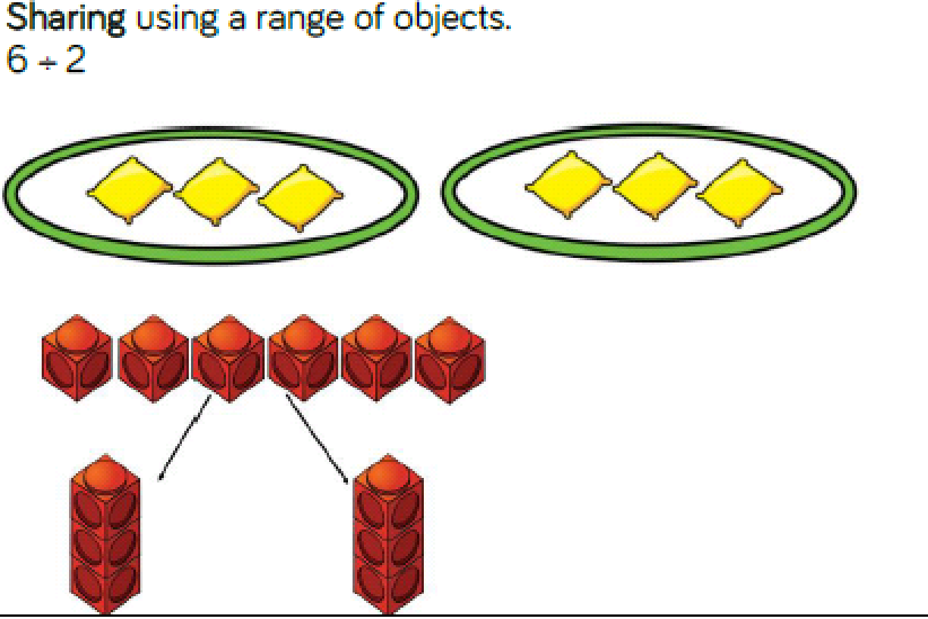  Children solve problems by sharing amounts into equal groups. |  |   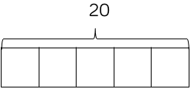 |  | 6 ÷ 2 = 3  20 ÷ 5 = 4  In Year 1 children use concrete and pictorial representations to solve problems. They are not expected to record division formally.  In Year 2, children are introduced to the division symbol.
1 step problems (grouping) |   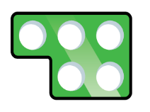    Children solve problems by grouping and counting the number of groups. They can use concrete representations, such as number shapes, which helps to show the link between multiplication and division. |  | 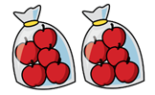  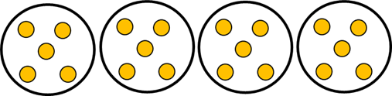 |  | 20 ÷ 5 = 4  10 ÷ 5 = 2
Repeated subtraction | 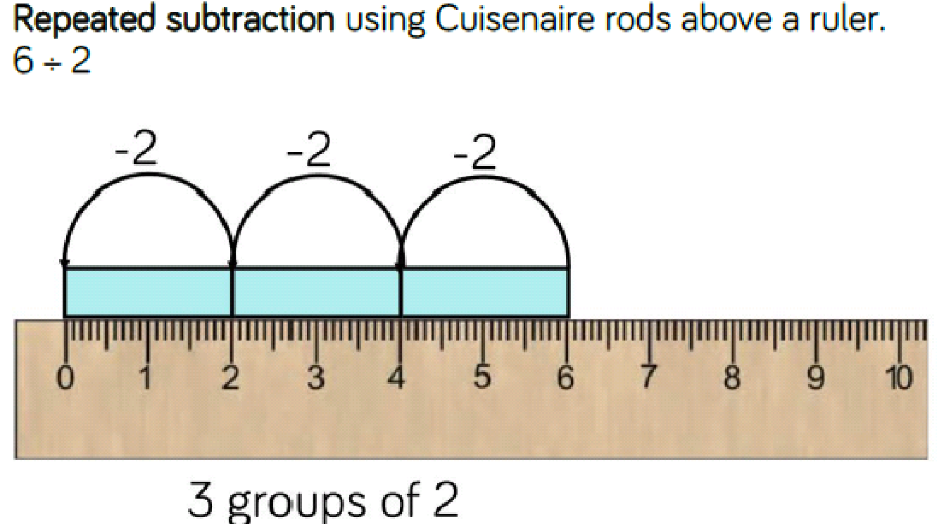 |  | 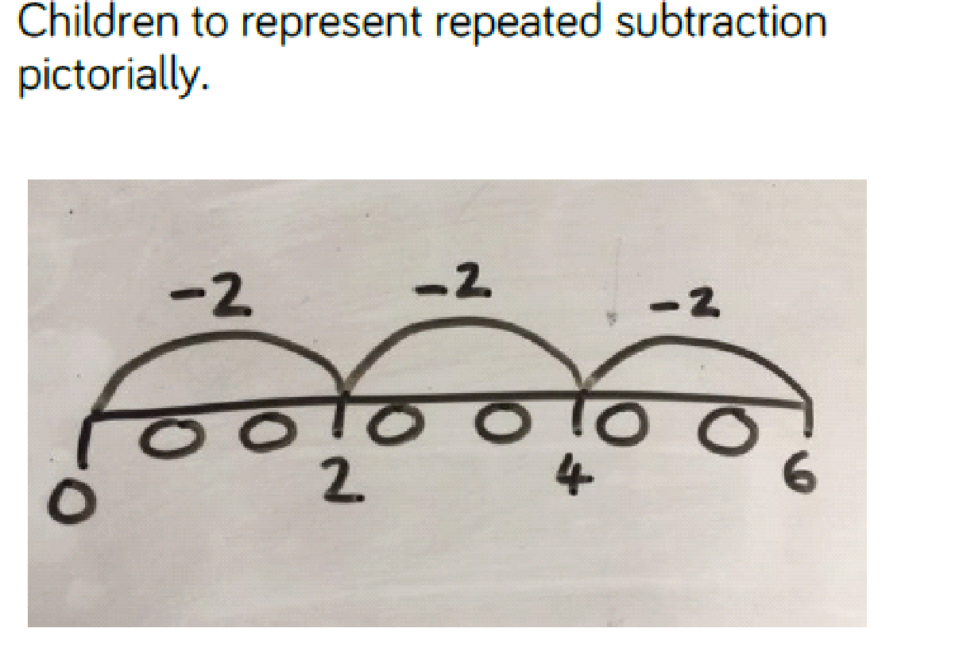 |  | 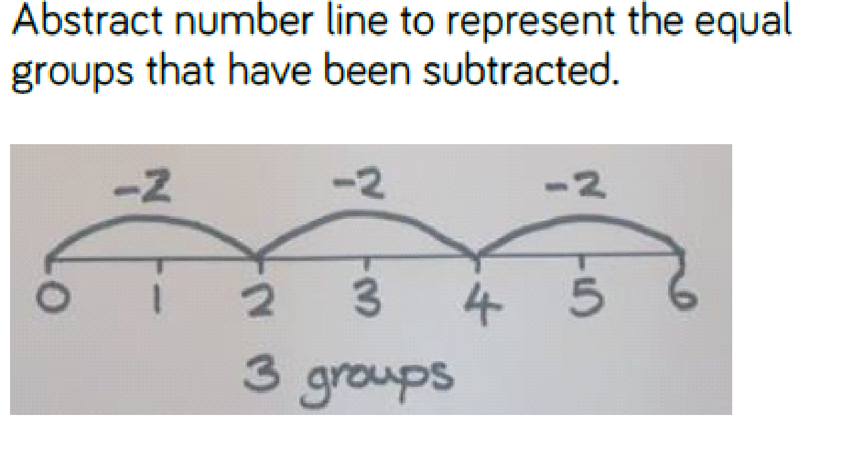
2 digit divided by one digit using known division facts (related to times tables) | 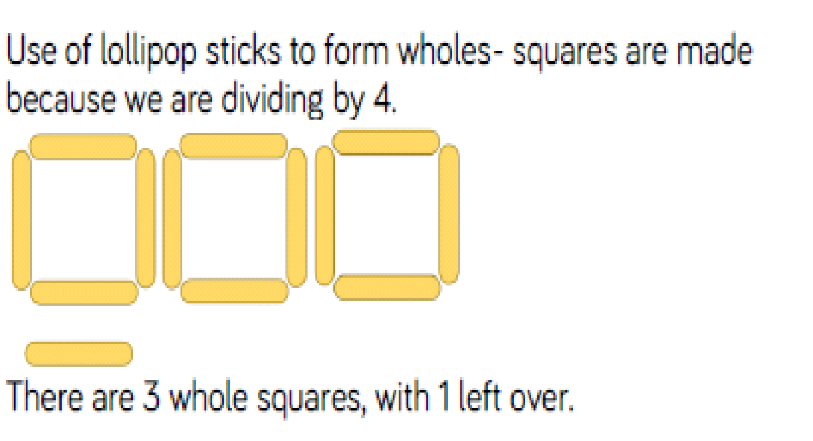  13 ÷ 4 =  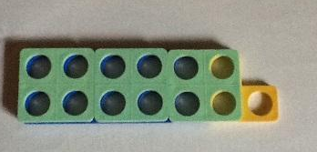  Using Numicon  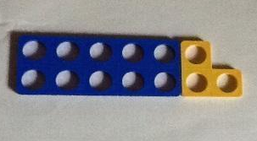 |  | 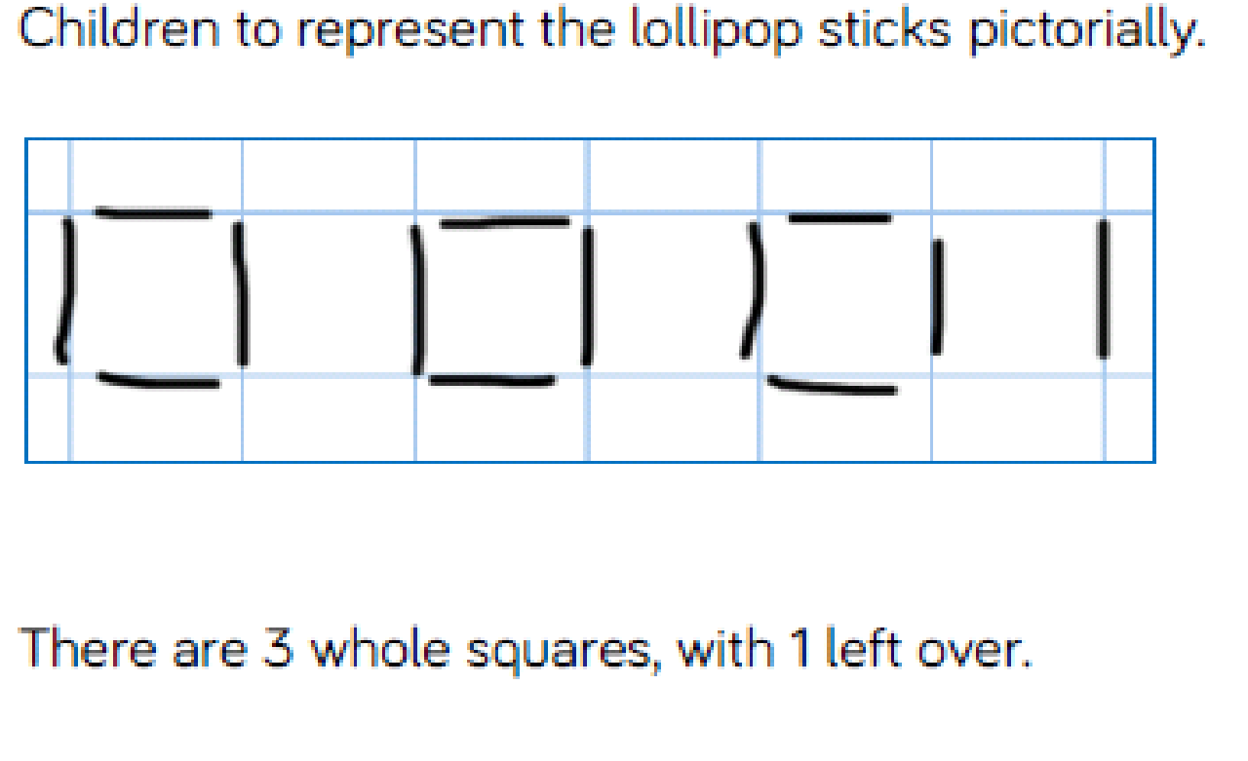 |  | 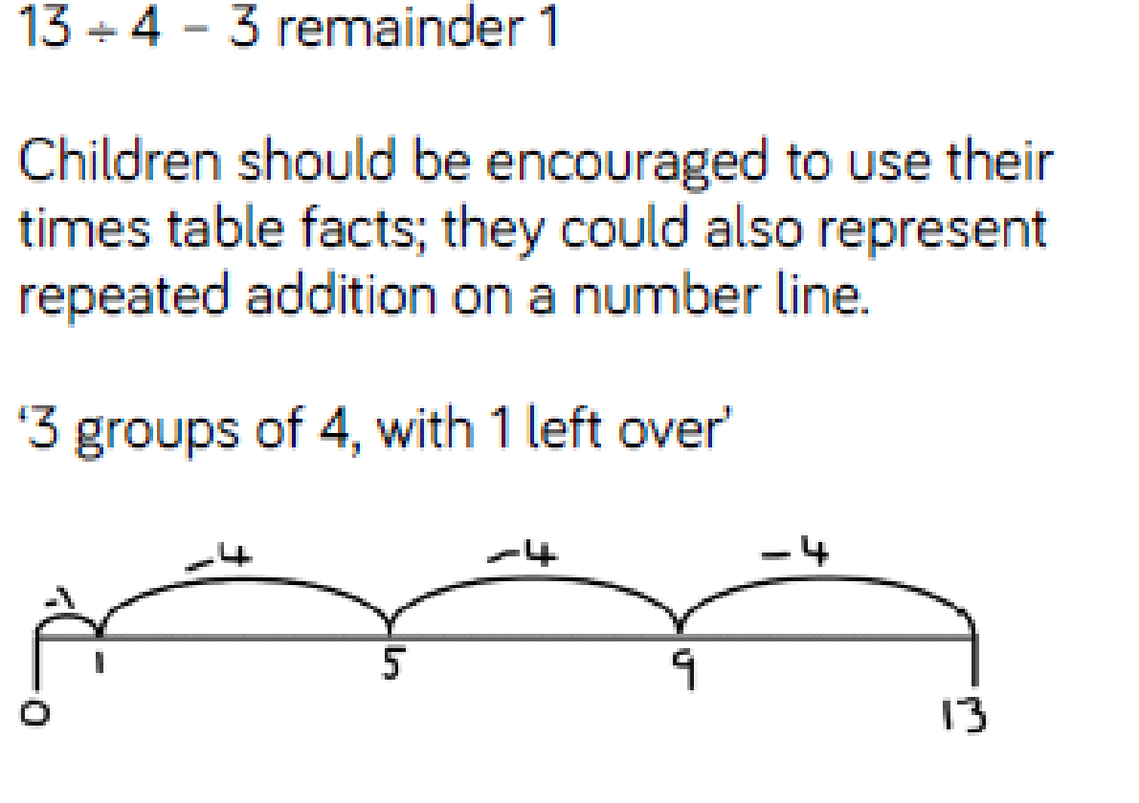
Sharing with remainders | 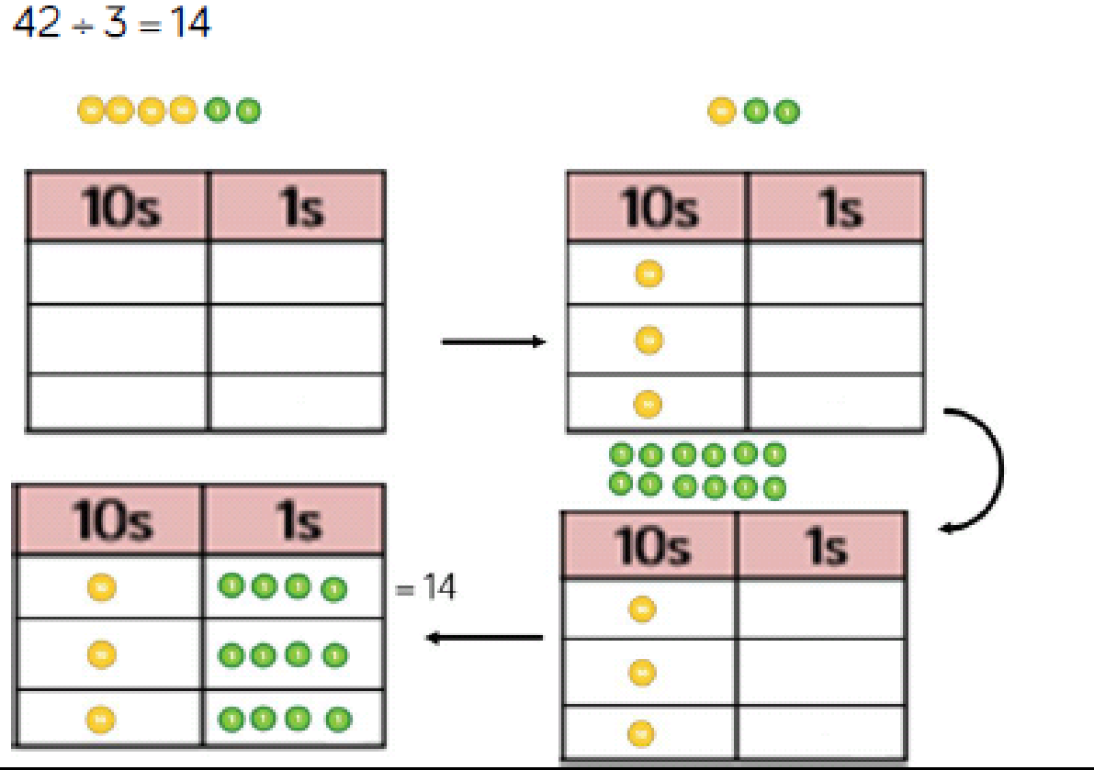  Using place value counters or Base 10: |  | 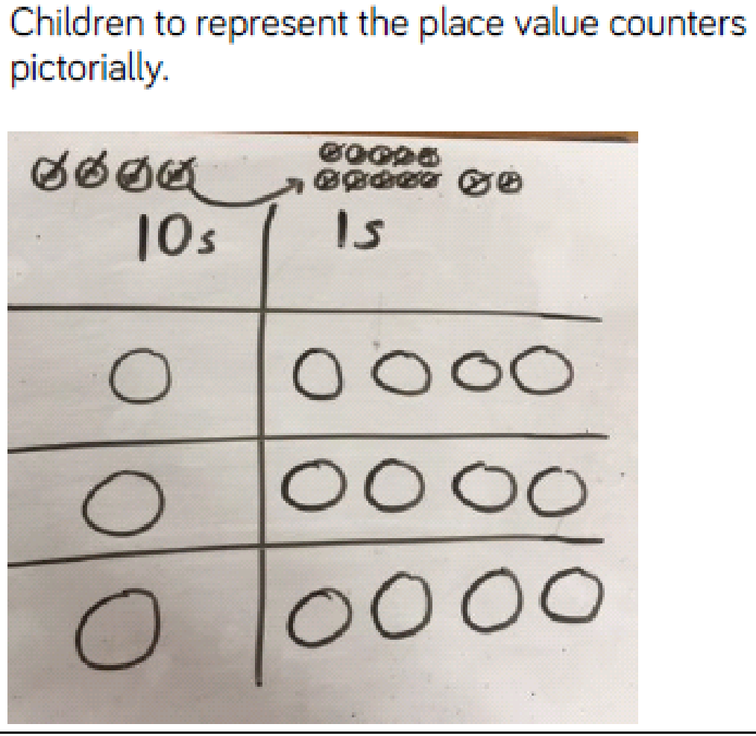 |  | 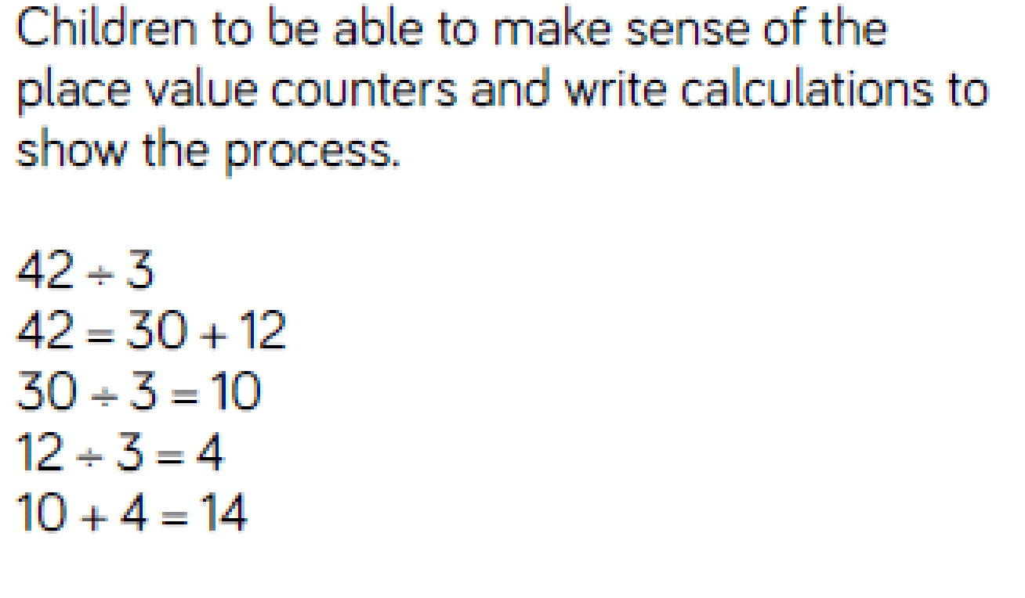
Short division (formal written method) | 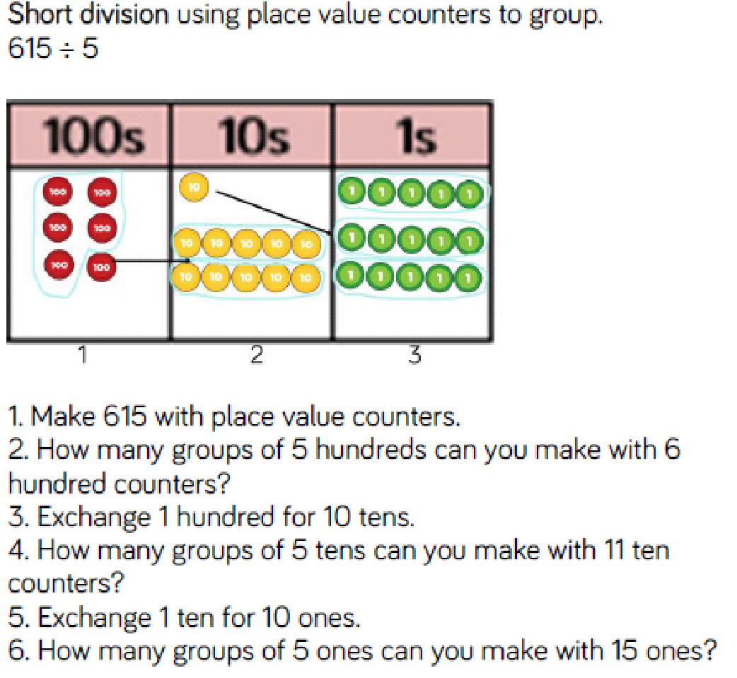 |  | 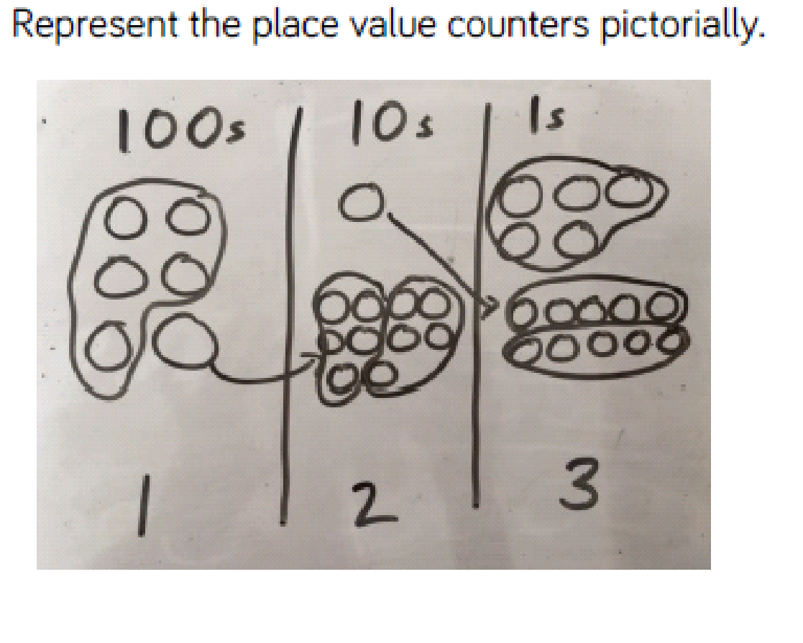 |  | 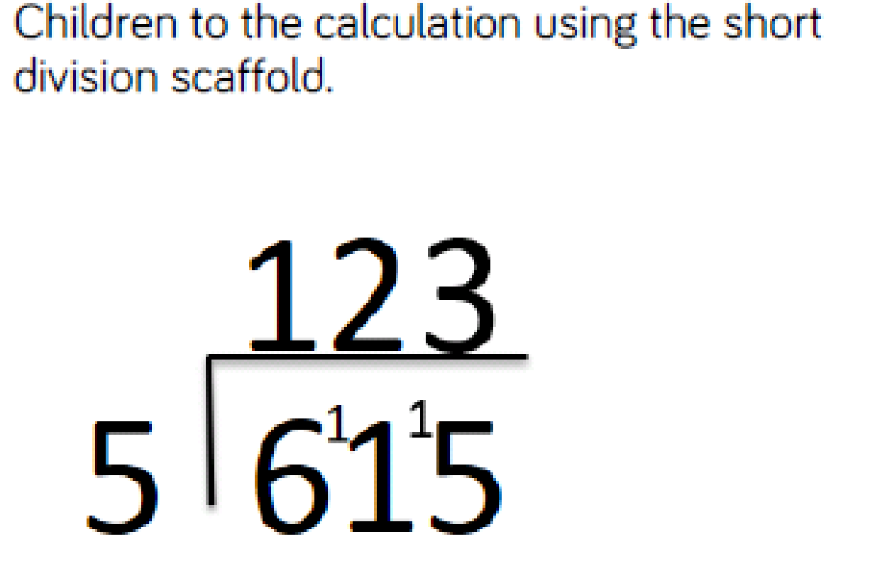
Long division (formal written method) | 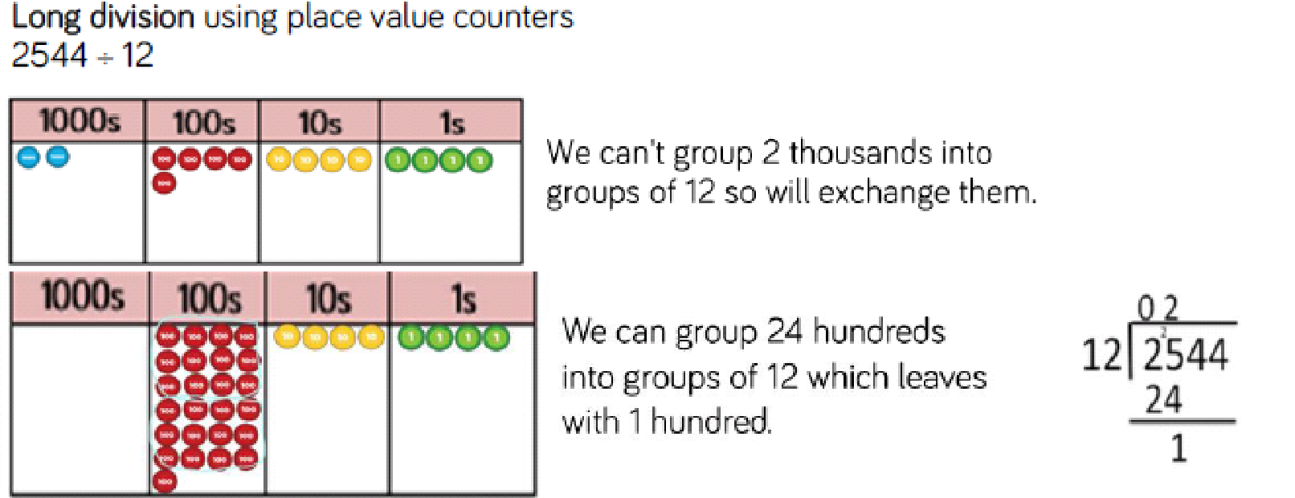  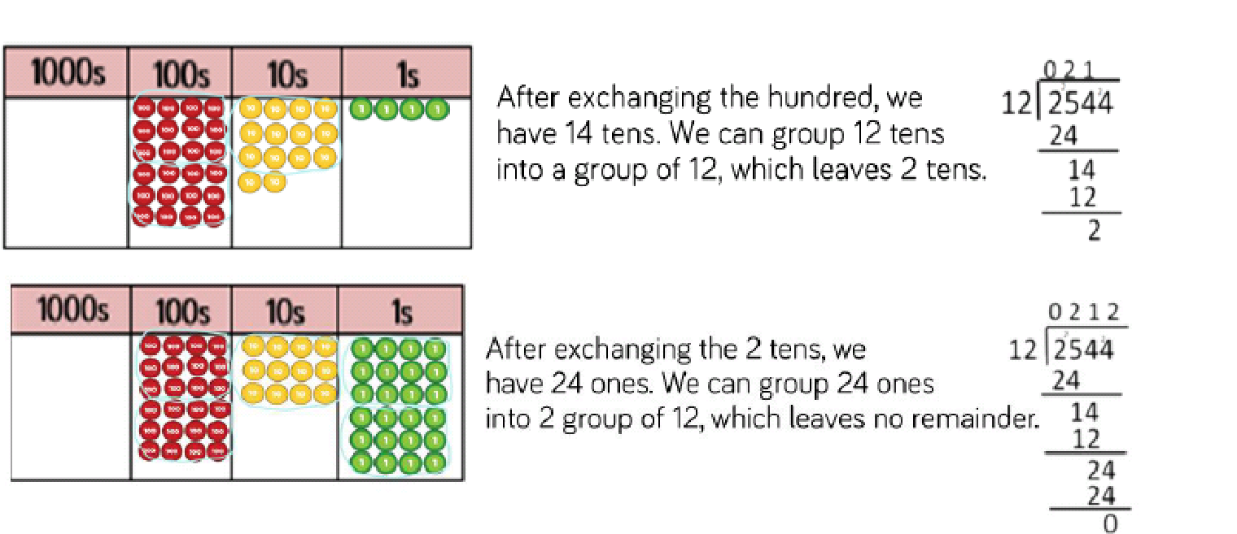  Get children to draw an arrow to show that they are now looking at the next place value column

Conceptual Variation; different ways to ask children to solve 615 ÷ 5
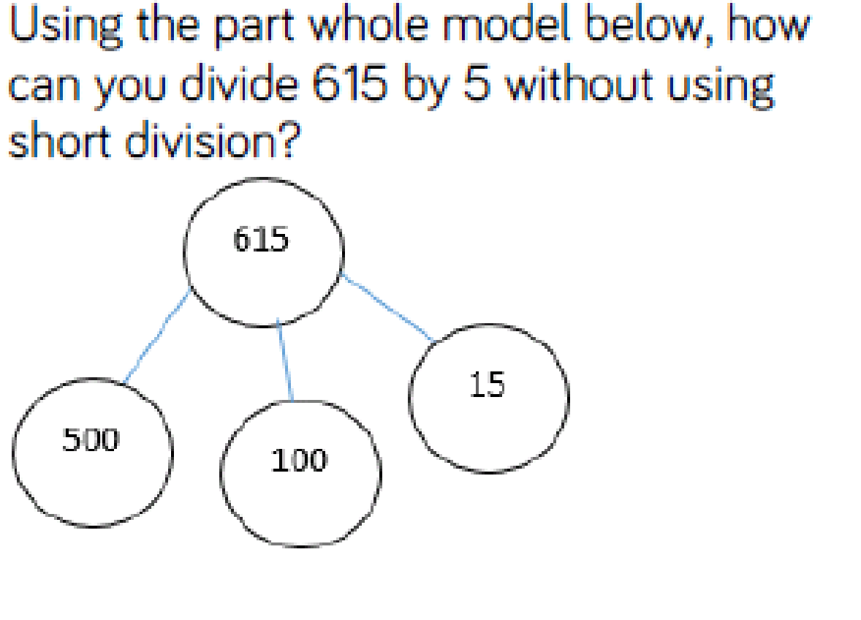 |  | 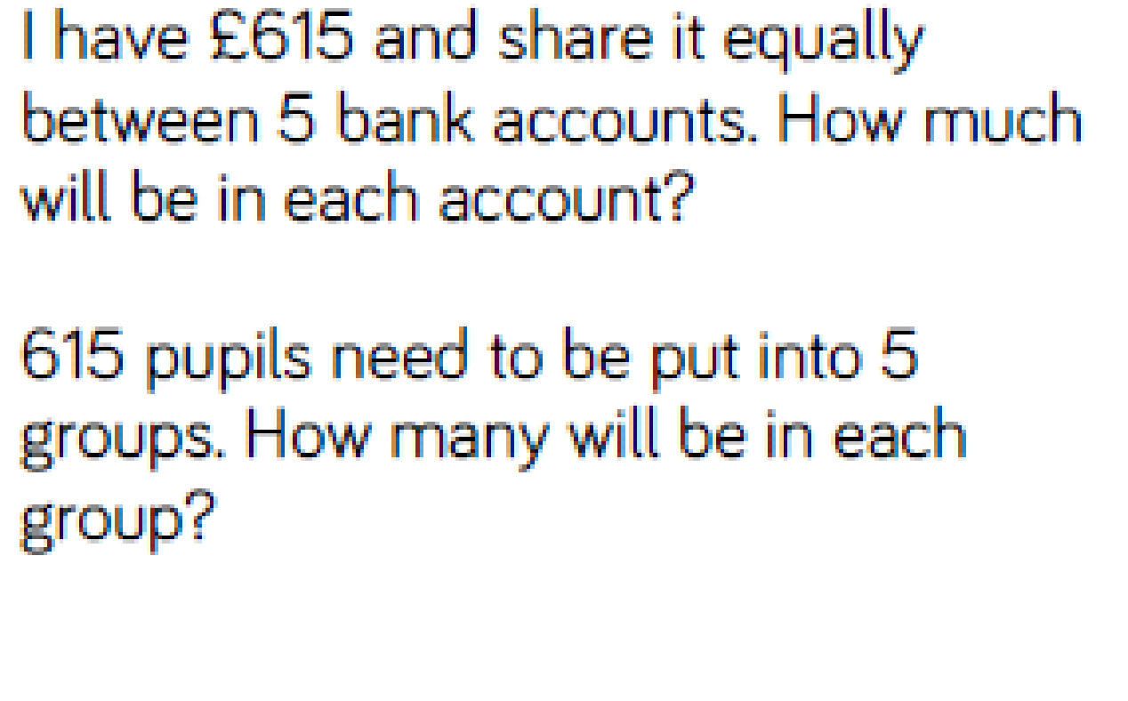 |  | 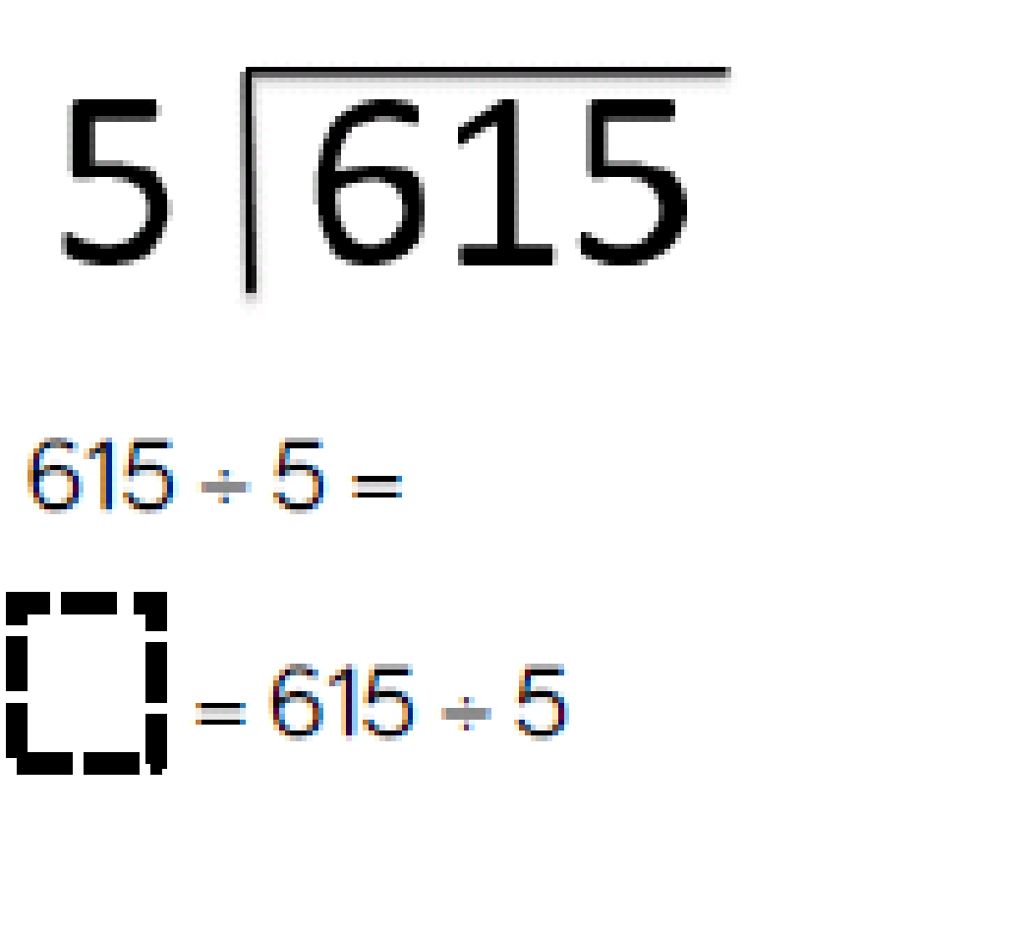 |  | 

